**MYSQL Notes:**

**Installation:**

1. Navigate to mysql.com and download the community edition of MYSQL.
2. Use MYSQL Workbench to work with the Database.
3. Create the password for the root user before installation and make sure to keep the network settings to default while installation.
4. After that connect to the SQL Server with the Root user credentials and you must be able to see the connection added in the connections section or else add a new connection with default settings.
5. Inside the Query area, we will be writing the queries necessary for the execution.

As an alternative to LIKE clause, we have **REGEXP** clause to match the string to be searched.

**Joins:**

1. **Inner join:** Joining the tables on the basis of the foreign key and primary key in both tables. Including the contents from both the tables.

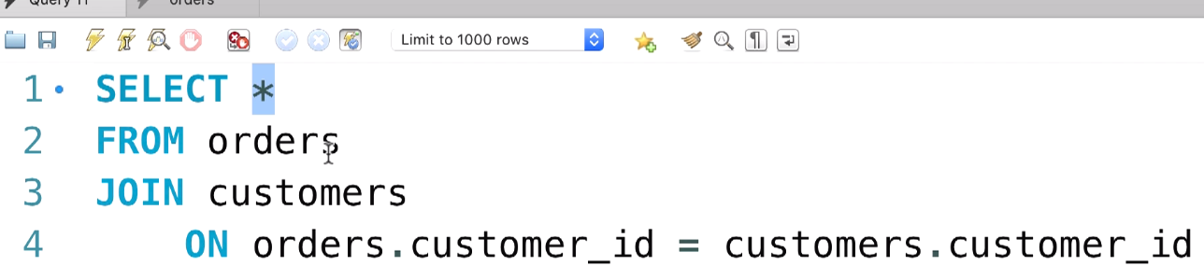

Here we have used the Keywords **Join and ON** to execute the inner join.

We have used the condition such that Foreign key in Orders is equal to primary key in customers table for joining the two tables.

We can also select the individual attributes from the table. When selecting the same named attribute in the table make sure to prefix it with the table name so that the ambiguity error doesn’t occurs.

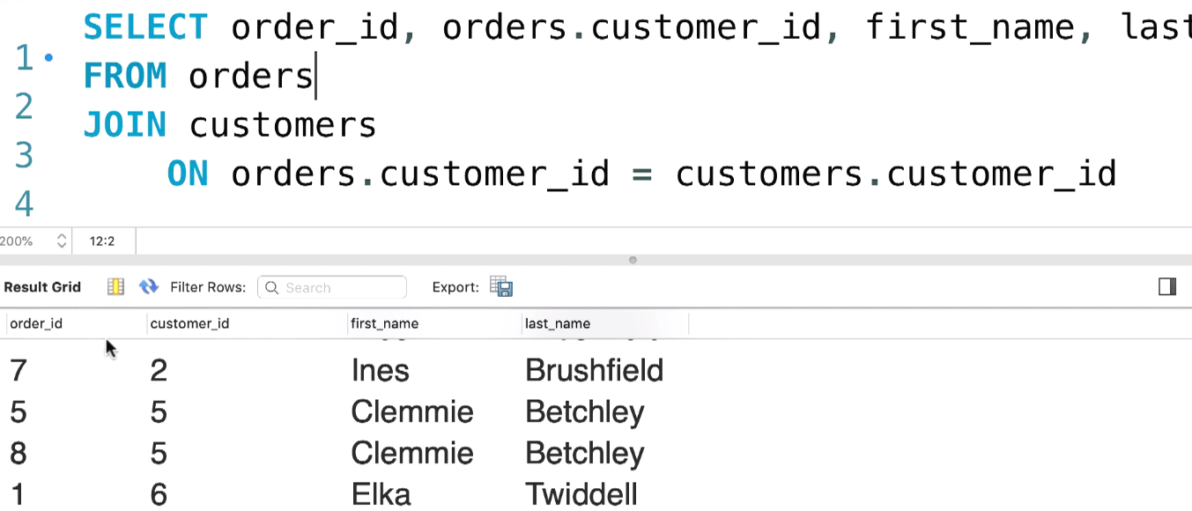

We can also provide the aliases for the table names like this:

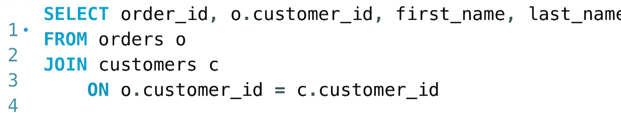

**Joining across Databases:**

Always use the **USE** clause to select the current database to work on.

So as we are working on the current database and we need to join the table from another database. We can use the following query to fetch the table from another db and join it using the inner join method:

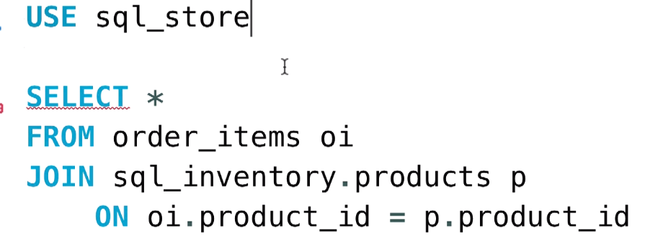

We are joining the products table from another table, so we have prefixed it with the db name.

**Self Joins:**

Suppose there is a need to find the reporting manager to the list of employees in the db. We can use Self JOIN in this case to create the organisation chart to find the reporting manager in the list of employees.

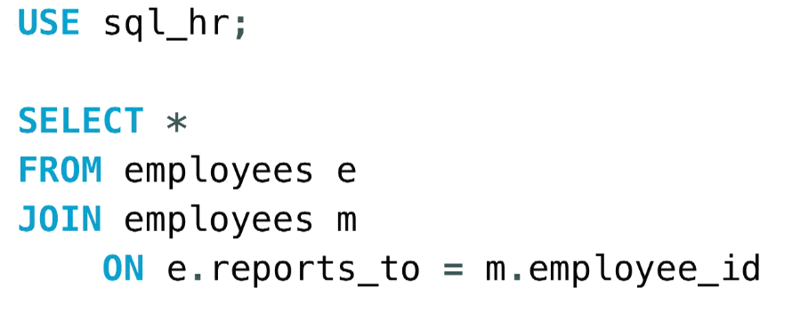

We will be aliasing the same table with different names and we will be joining the table based on the reporting ID with the employee ID to find the reporting manager details.

Since we have a separate tables now with managers and employees, we need to print the firstname and empID of the employees and firstname of the managers. We can use this:

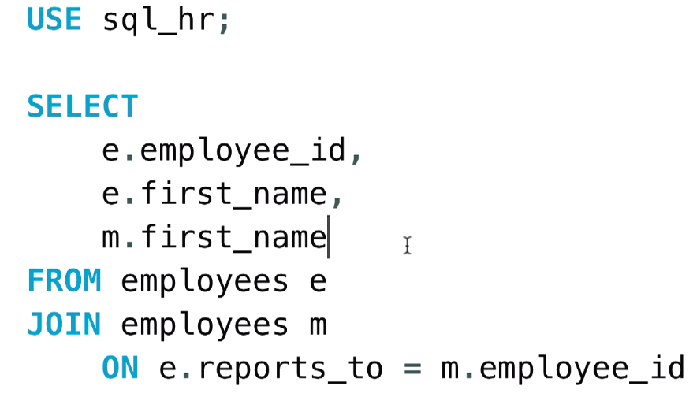

**Joining multiple tables:**

In the real world we may get the necessity to join more than two tables to get the better results.

We can join two tables in this case by using the following query:

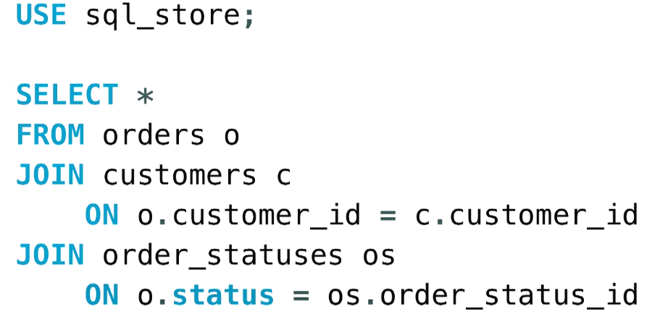

First we joined the table orders with customers by using the foreign key in orders and customers named **customer_ID.**

Next, we joined the orders and status table by using the foreign key in orders and primary key in the status table named **status** and **order_status_id** respectively.

Now to get the better report, we will be selecting only required columns from the joined table.

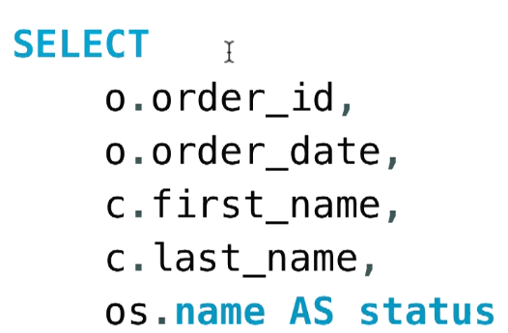

**Compound join conditions:**

In some conditions, we cannot use the ID column to uniquely identify the condition for joining the tables. We use the combination of two columns for the condition.

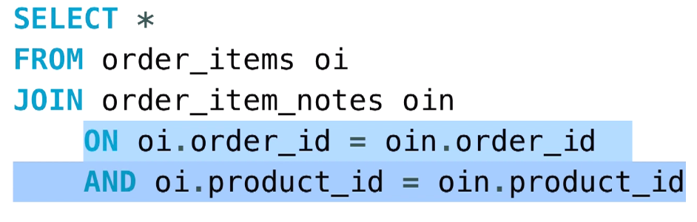

We have used these columns because they are the primary keys in design and due to the composite primary key scenario, we have used this AND clause to condition them to get the required answer.

**Implicit Join Syntax:**

We can write the inner join sql query with the implicit join syntax like this:

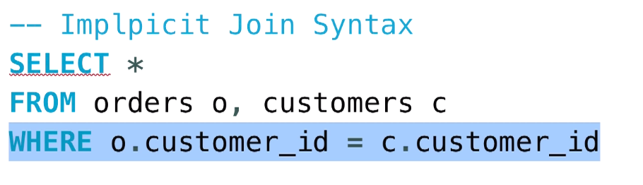

If we forget to write the **WHERE** clause, then we get an accidential **CROSS JOIN** i.e. Every record in orders will get mapped to the every record in the customers table and 10 records result in 100 records.

**Outer joins:**

If we use the inner joins, then we get the result if the customers/ records meet the provided condition only, and the others are omitted out.

Eg: 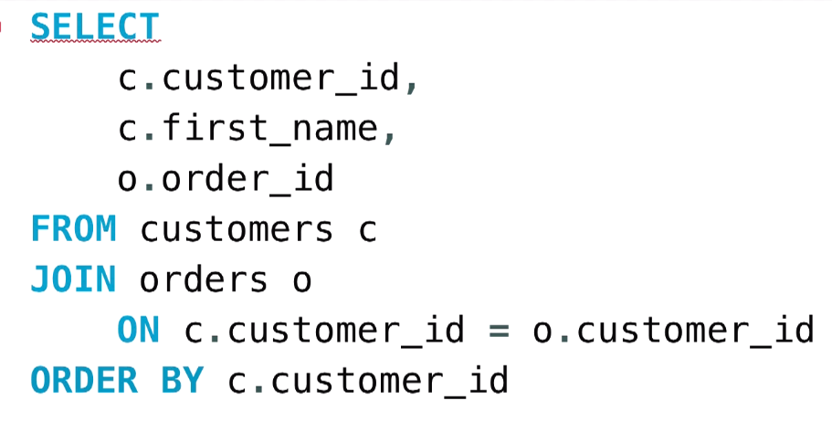

We get the customers who have the order ID meeting the condition and others are omitted out, if we want all the customers without orders to be printed too then we use the outer joins concept.

We have two types of outer joins, namely LEFT OUTER JOIN and RIGHT OUTER JOIN.

If we use the left outer join, then all the records in the left table (first table) will be returned even though they don’t meet the requirements.

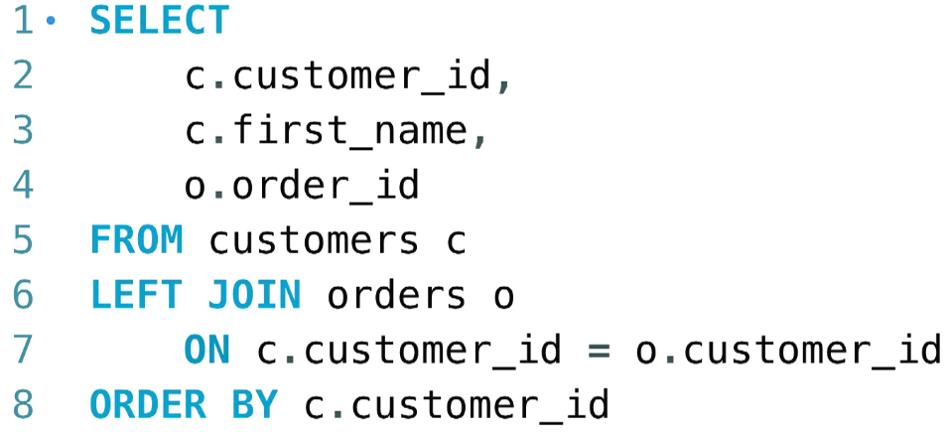

The output will contain each and every name from the left table irrespective of the condition:

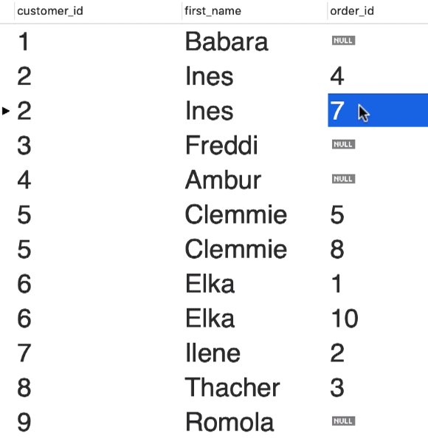

The same applies for the RIGHT OUTER JOIN too.

We can omit the OUTER word as we already use the LEFT and RIGHT keywords.

**Outer join between multiple tables:**

We need to use the LEFT OUTER JOIN to get all the details from the left table and then write the INNER join to join the multiple tables into a single table. But it will create the same problem as before and the NULL values will not be taken into consideration.

So as a replacement for INNER JOIN we will be using the LEFT OUTER JOIN to implement the JOINING between multiple tables.

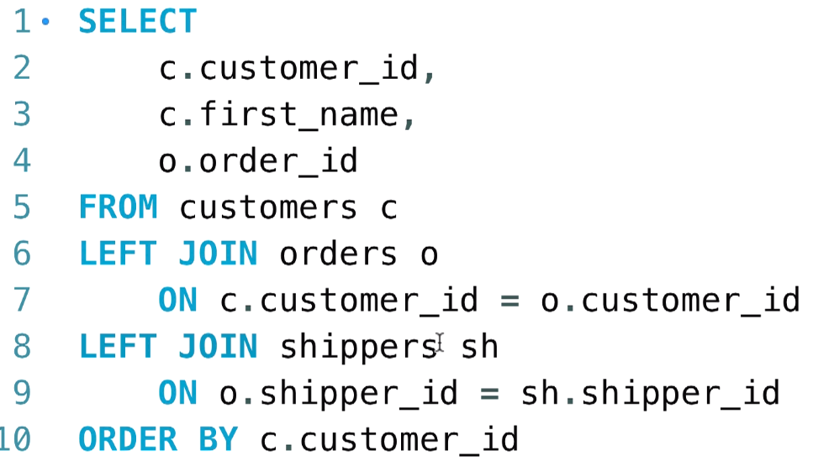

As a best practise, always use the LEFT OUTER JOIN to make sure that the next programmer gets the good idea about our SQL Query.

**Self outer join:**

We will be using the SQL_HR Database to get the self joins and create the output for the employees that are reporting to their managers.

By using the INNER JOIN Method, we get all the employees reporting to the manager, but we don’t get the record for the CEO because he reports to NULL.

TO get this, we need to use the OUTER JOINS.

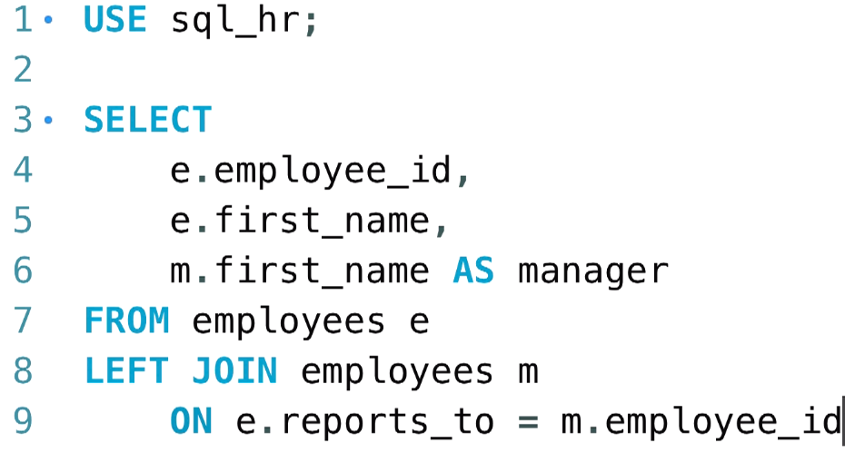

**USING Clause:**

As the JOIN conditions get more and more in the queries, our query becomes hard to read. If we have same attribute name for the FK and PK used to join the tables, we can use the USING clause to simplify the query.

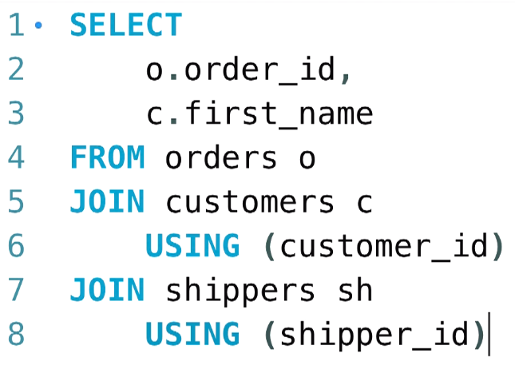

We can use the USING clause with either INNER or OUTER joins.

Beware: We can use it only if the column names are exactly same.

If there are composite PK to be compared then:

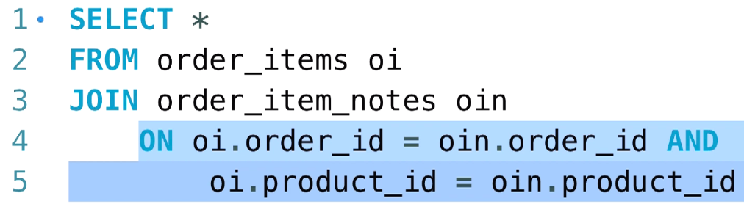

We can replace this messy query with:

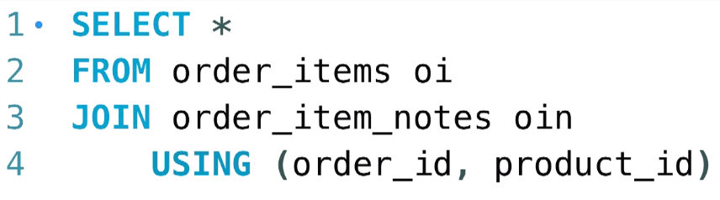

**Natural Joins:**

We don’t explicitly mention the column condition to be joined here, SQL will automatically look for the common columns and perform the JOIN operation.

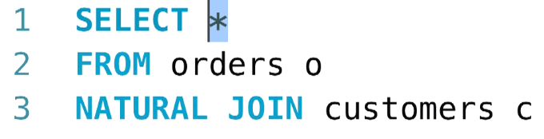

It may cause the unexpected results, so mostly it is not recommended.

**Cross Joins:**

Every record in the first table is matched with every record in the second table resulting in (mxn) records where m and n are the records from first and second tables respectively.

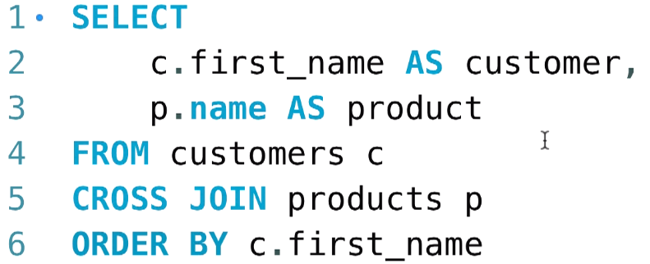

Implicit Syntax:

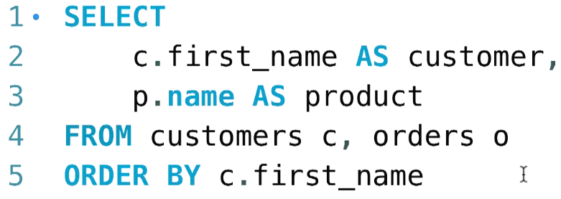

**Unions:**

Combination of Records from multiple tables using Unions.

Suppose, we need to have a list of orders placed yearwise and then mark the latest as active and the oldest are archive.

We can use unions for this:

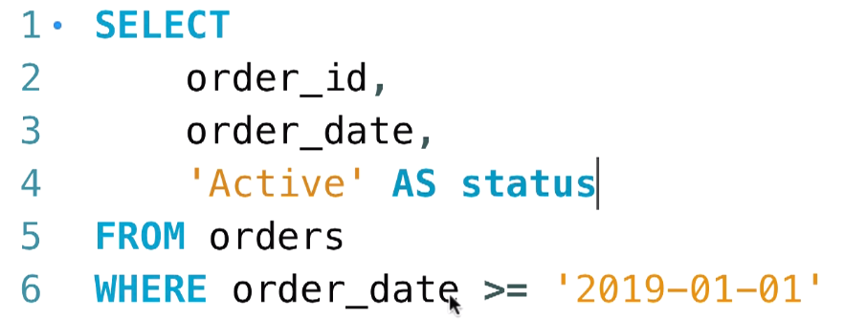

Use the same query to get the records less than 2019-01-01 and label it as **archived**.

Perform Union on these.

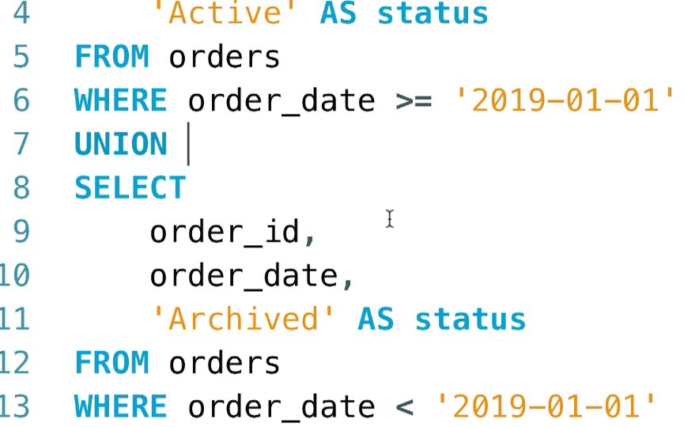

We can also perform union for multiple tables like this:

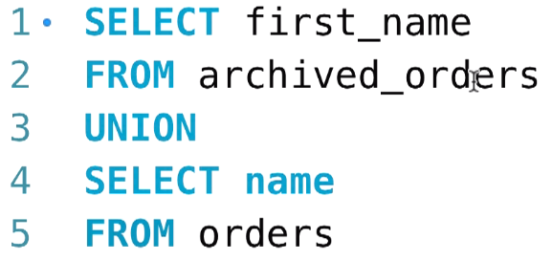

**Beware: Make sure to use same number of columns while using UNION on multiple tables.**

The column name depends on the left table so we get the column name from the attribute used on left table.

**Inserting into multiple rows:**

We can insert the new rows into the table using the values clause separated by commas:

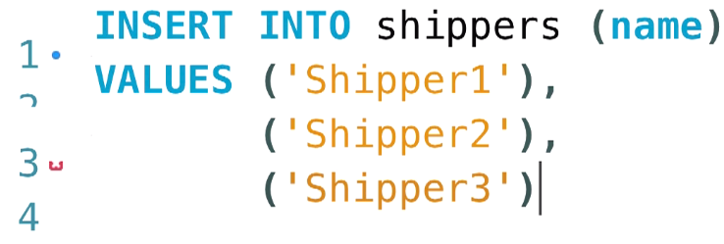

The values are inserted at the bottom and the ID has been generated for those entries.

Note: If you had deleted the entries from the table, then MYSQL remembers the IDs of those entries and the new entries will get the ID after them.

**Inserting hierarchical rows:**

Consider ordering items scenario, the orders table will be the parent table and then order_items will be the children table.

Generally, we are inserting the values into multiple tables.

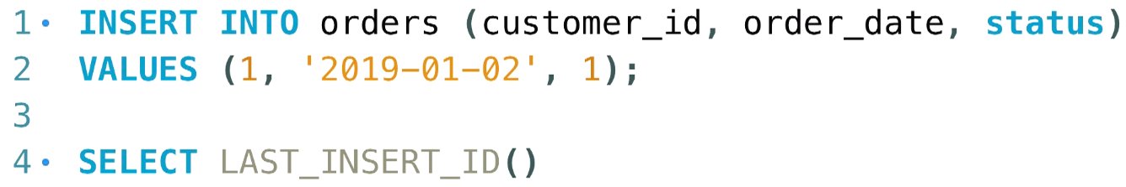

Here we get the entered INSERT ID of this customer.

The final query for entering the rows into multiple tables is as follows:

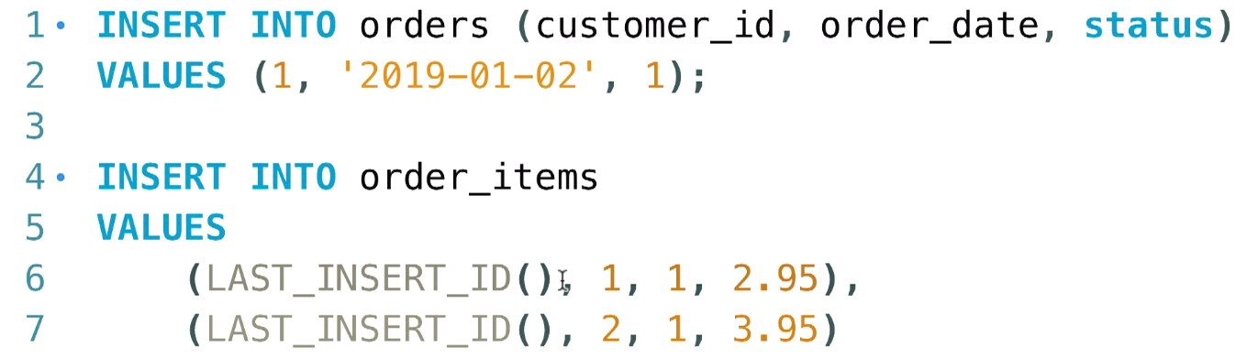

Here we get the data entered in both PARENT and CHILD tables i.e. ORDERS and ORDER_ITEMS.

**Creating a copy of the table:**

Suppose we need to create a new table named “Order_archive” to copy the data from the orders table.

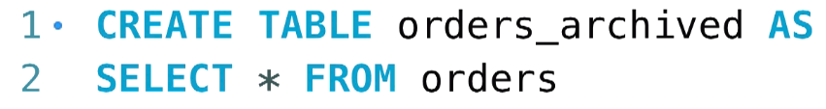

We get the copy of the ORDERS table inside the Orders_archived table and we don’t have the primary key inserted for it.

Click on the ORDERS_ARCHIVE table and then right click to select the option **Truncate Table** for permanent deletion of the contents in the table.

So for eg, if we use the select query to get the specific set of data then, use it as a sub-query and create a new table.

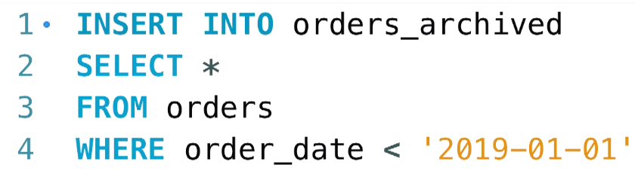

**Updating a single row:**

We can update the single or multiple entries of the table using the UPDATE..SET..WHERE clauses.

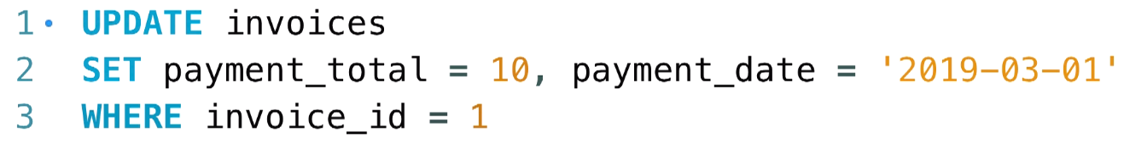

Suppose, we have updated the wrong record then we can restore it back by entering the previous values in the above query:

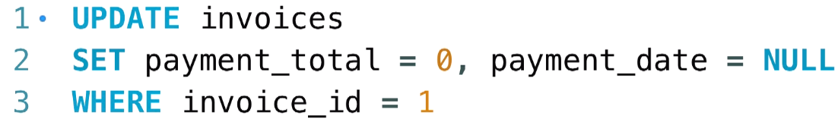

Suppose we want to update the values using the expressions and the already preset values then,

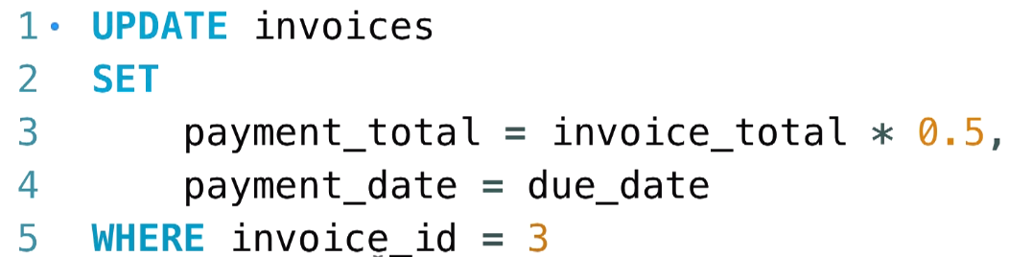

**Updating multiple rows:**

By default MYSQL runs on SAFE_UPDATE mode that allows only one rows to be updated at a time.

Go to the WORKBENCH menu and then go to PREFERENCES > Navigate down and untick the SAFE UPDATES option and then restart the SQL Connection.

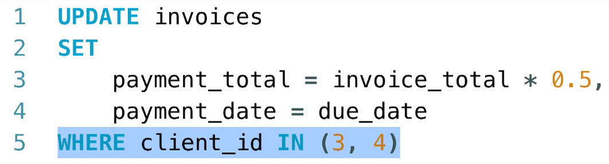

**Using subqueries in Updates:**

Suppose we need to update the details of the client by dynamically selecting the client as per the requirement then:

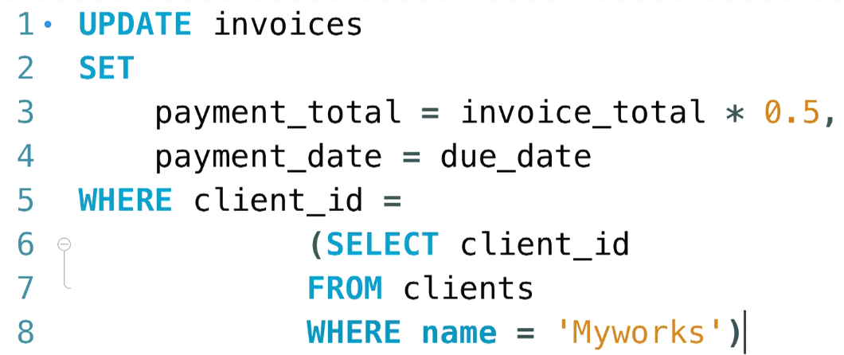

Always make sure to test if we are updating the correct records, by writing an select statement for the subquery and executing the subquery first and then appending the subquery to the main query.

If we are updating with multiple records, then use IN instead of =

**Deleting Rows:**

We can delete the contents of the table using:

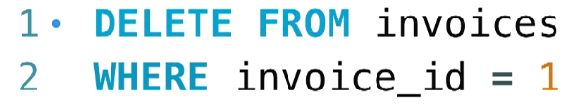

We can also perform the deletion of data by fetching the data from the subquery:

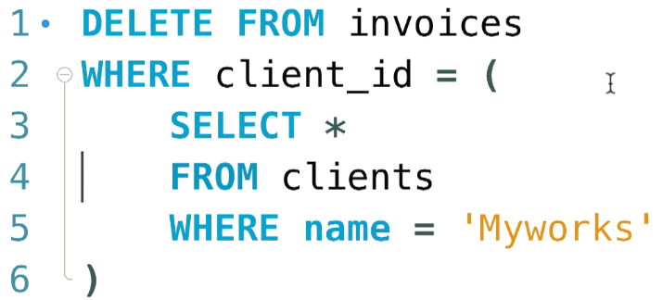

**Aggregations:**

Some of the functions that take aggregate values as input and produce the single value result are:

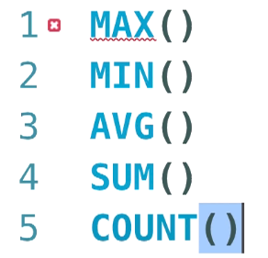

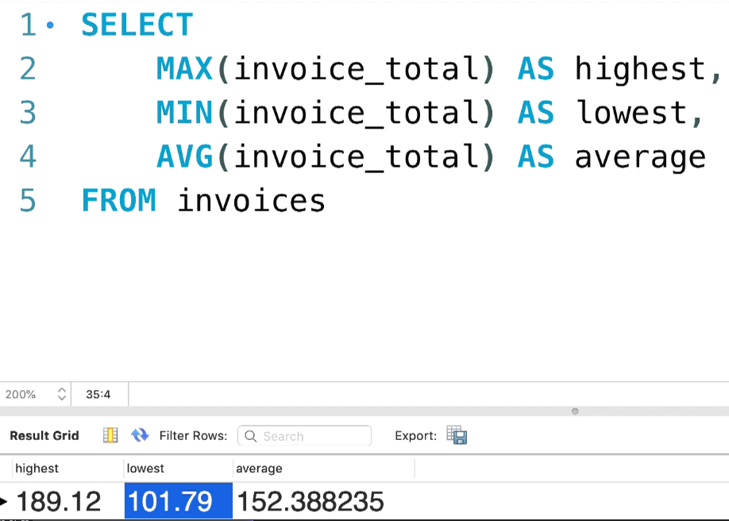

**The Group By Clause:**

Consider the scenario of getting the sum of the invoices per client we have used the group by clause for this:

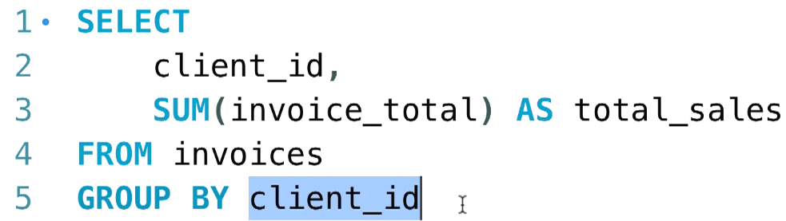

Now we want to print the total sales for the clients after the half year, that is from July to December, then we use the following query and we have also sorted the details in the descending order depending upon the client ID:

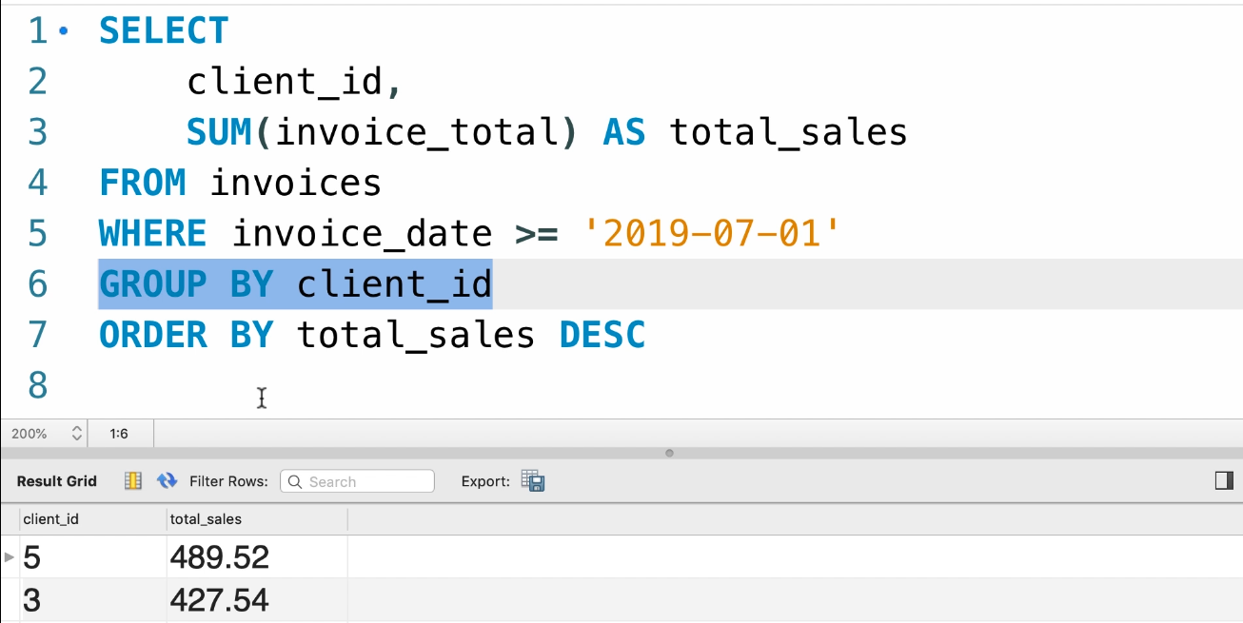

**Always remember the order of the clauses:**

**SELECT, FROM, WHERE, GROUP BY, ORDER BY**

Now we will be getting the information using the multiple columns, we will be joining the two tables Invoices and Clients. From Clients we will be getting the **city** and **State** attributes.

Now we will be selecting the total sales based on the city and state.

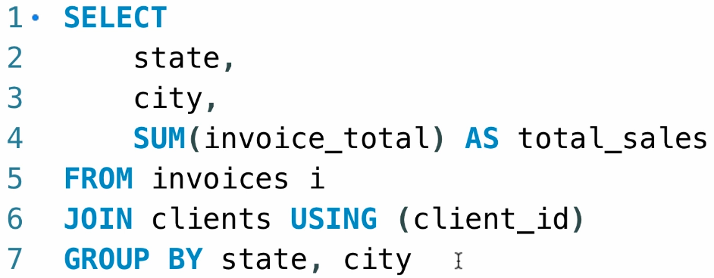

Lets perform an exercise:

Consider that we are grouping by the DATE and PAYMENT method and then calculating the total and printing the results. We use the following query to perform GROUP BY for multiple attributes:

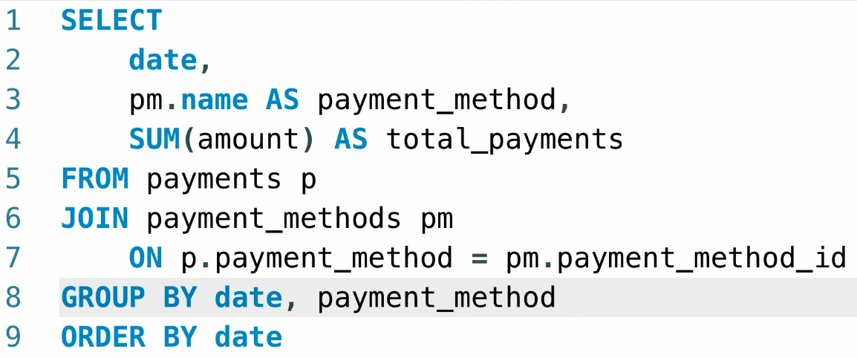

First task is to join the two tables based on the PK and FK, we cannot use the USING clause here because there are different names for the PK and FK.

After that we will be selecting the attributes from the two tables and then GROUPING by date and PAYMENT METHOD and ordering the date in ascending order.

**HAVING clause:**

Suppose that we need to get only the sales above the provided quantity and we cannot use the WHERE clause for getting the conditions done here, because we are grouping the data only after the WHERE clause, so we need to use the HAVING clause.

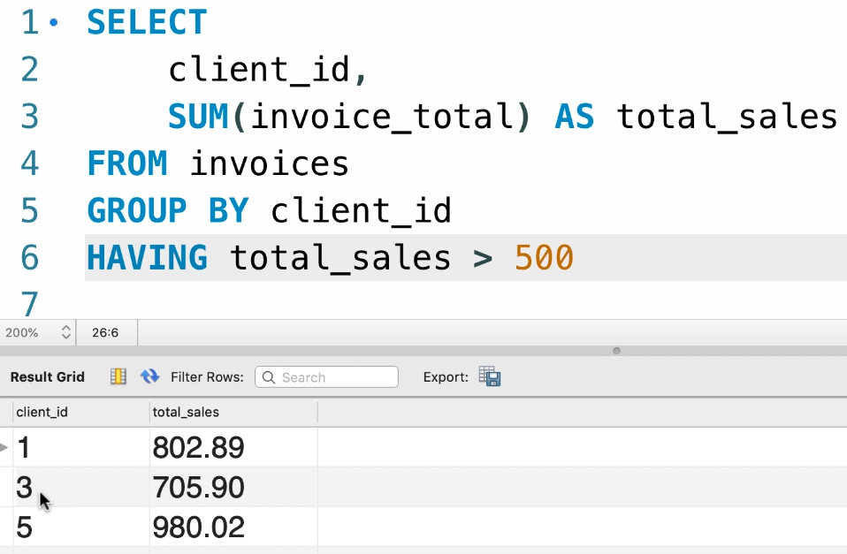

Now we see that we get only the total_sales above 500

Suppose, we want to have the searching done on compound conditions, such that total_sales > 500 and number of invoices > 5 then we can use this query:

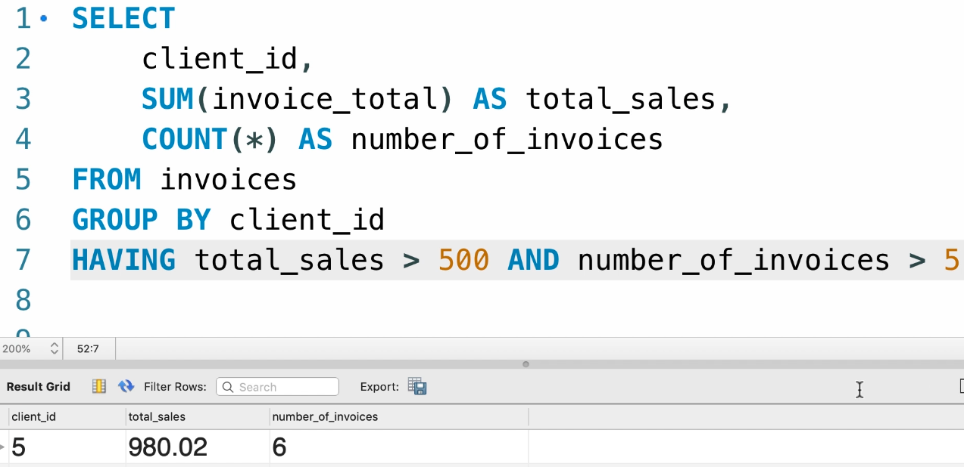

**REMEMBER: For including the attributes in HAVING clause, the attributes must be there in SELECT statement and for WHERE clause, it is not needed.**

Lets do an exercise:

Print the total amount spent by an individual customer in Virginia and cost must be greater than 100$.

We need to join three tables here, because there is no link between customer and the sales. So we will be joining the Customers, ORDERS, ORDER_ID tables

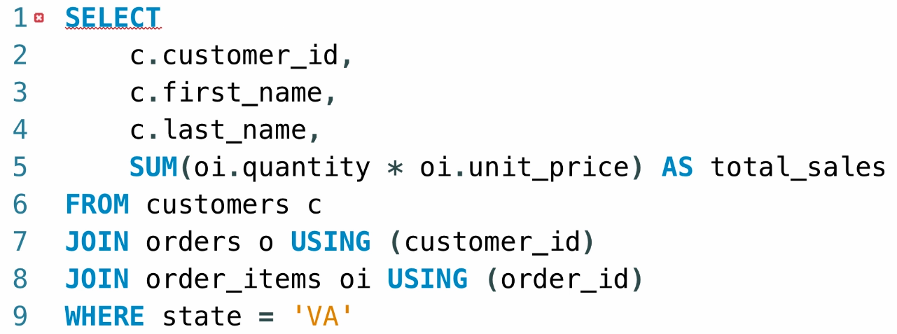

As we have used the SUM aggregate function, as a rule of thumb we need to use all the attributes in SELECT for grouping the data.

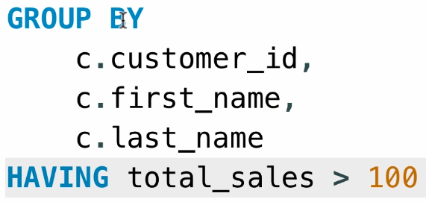

Now we have grouped the data and then searched for the grouped attributes for sales > 100.

**ROLLUP Operator:**

Rollup operator is used to summarise the rows in the columns that have been aggregated by using functions like SUM, etc.

We get the summarised data for single grouped row.

Suppose we are grouping the city, state and then the total_sales, we get the summarised data for each row here.

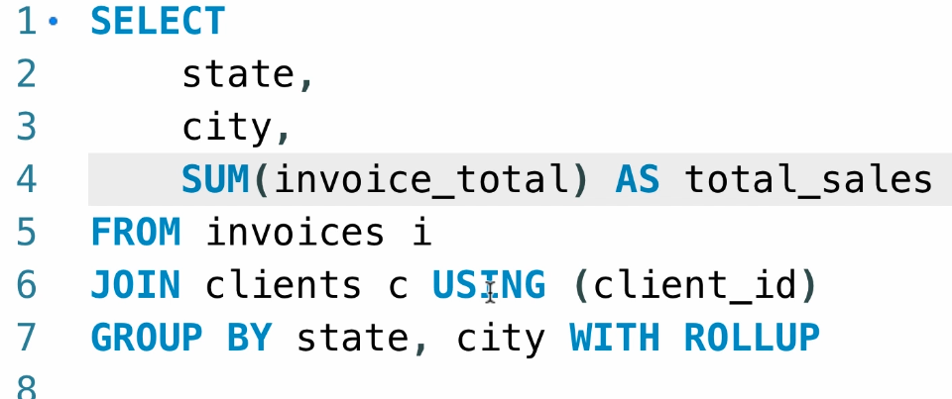

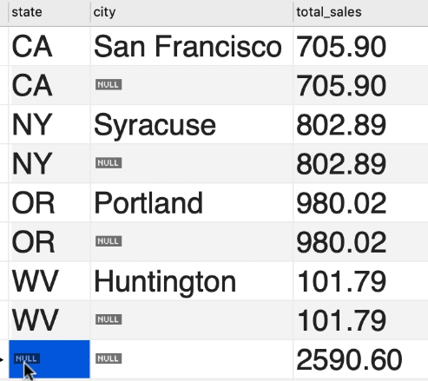

For each city, in each state | For all cities in each state | For all cities in all states

**Writing Complex Queries:**

We start off by writing the SubQuery for a simple problem:

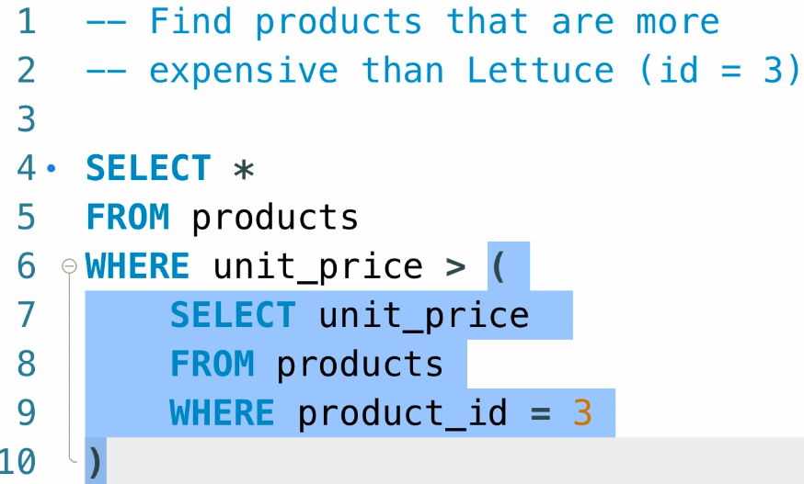

A simple exercise on SubQueries:

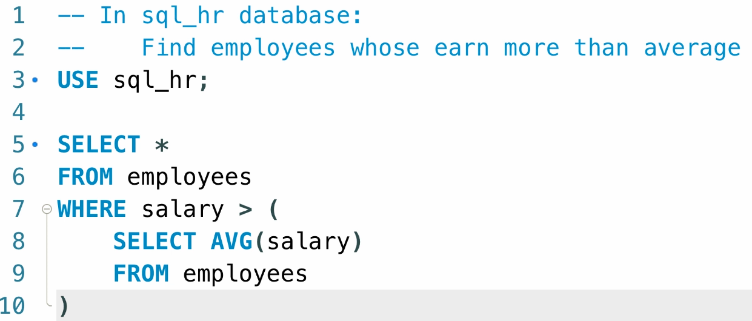

**Writing the SubQuery using the IN operator:**

We will be returning the product that has never been ordered:

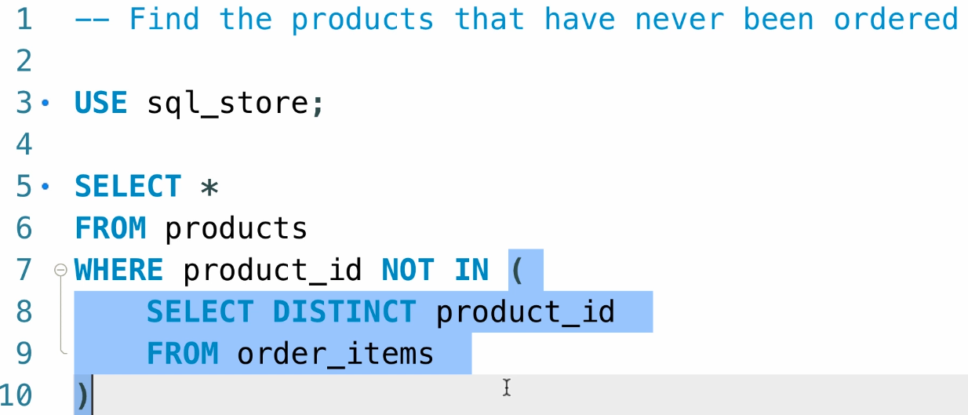

An simple exercise:

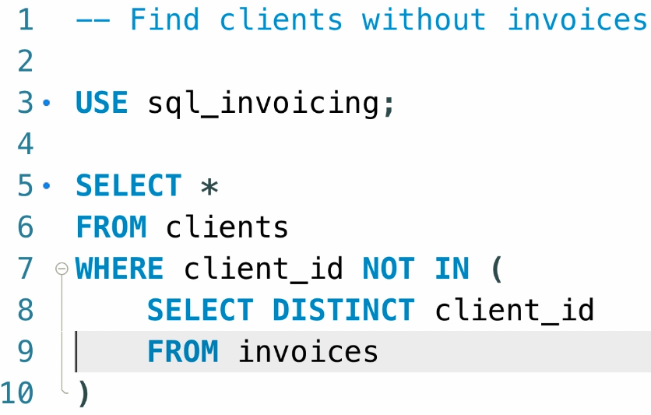

**Joins vs SubQueries:**

We can always use the Joins and SubQuery method to get the desired results with vice versa. We need to take care of the readability and query optimisation for the choice.

Consider a simple exercise:

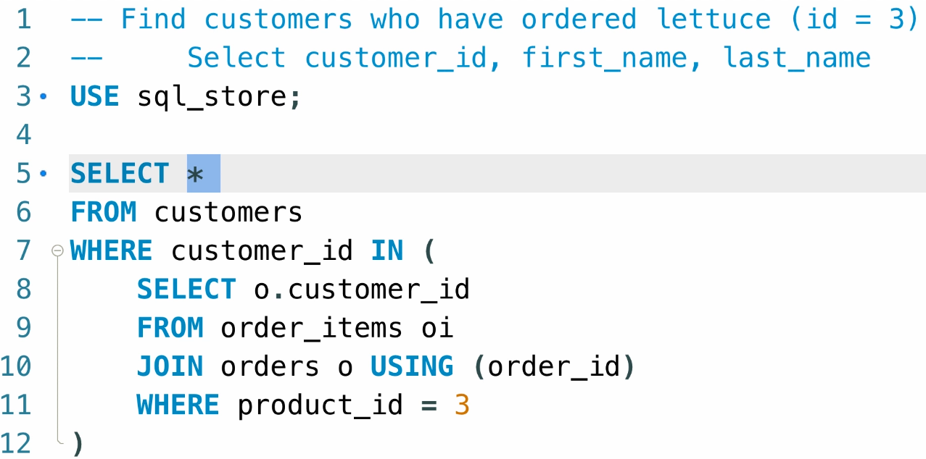

We have used the IN operator for fetching the data and now we will be using the JOIN to get the same results:

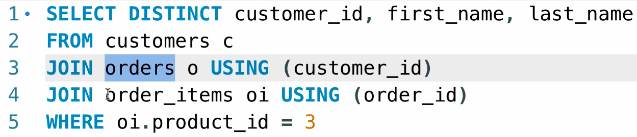

Both work fine here, but we need to select the one with more readability.

**All Keyword:**

While writing the subqueries, some of the subqueries return the list of values, so if we want to check over the list of the values, we will be using the ALL keyword.

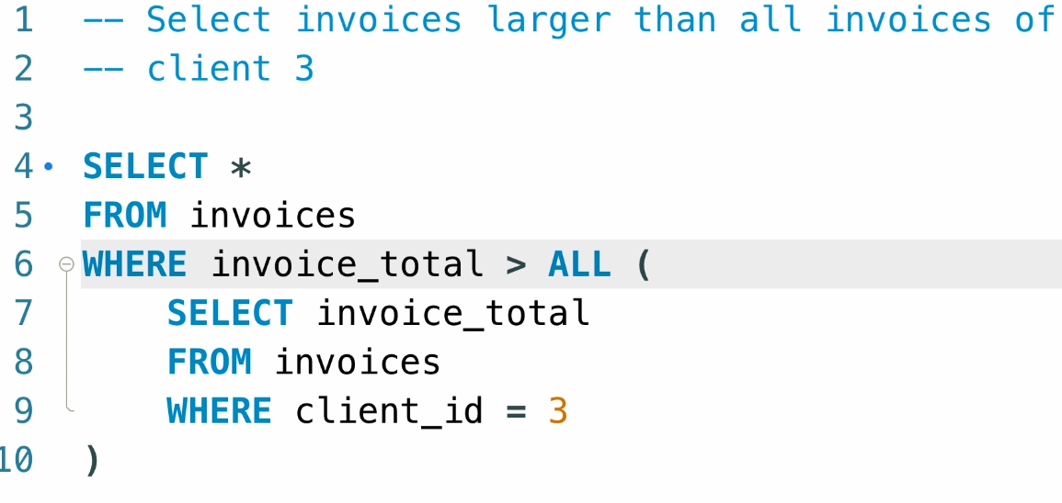

**ANY Keyword:**

We need to perform the operation such that we need to get the value that must be in any of the value returned from the subquery, then we can use the ANY keyword:

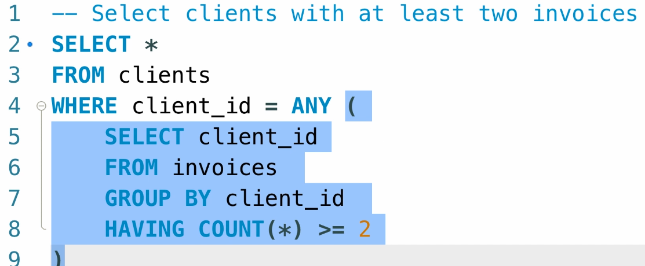

Logically IN is equivalent to “= ANY” keyword.

**Correlated SubQueries:**

The subqueries that make use of the main query and then we perform operations on both sub and main queries is called as correlated subqueries.

Just like a loop, executing until the main query gets satisfied.

Eg:

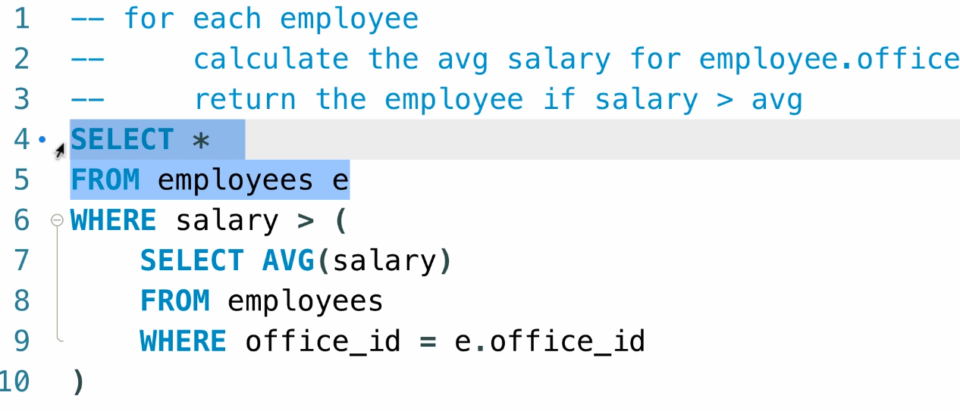

Correlated queries are powerful but yet they are slower as the data goes on increasing.

An exercise on this:

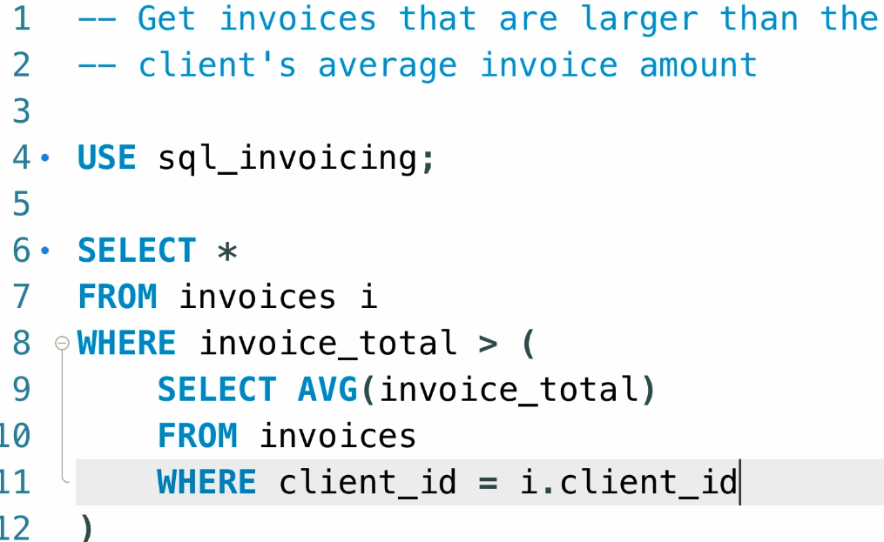

**THE EXISTS OPERATOR:**

Suppose consider the scenario of getting the clients that have the invoices.

We can solve it by many ways, we prefer the IN method and EXISTS method.

If we use the IN method, it will return the ID of the clients to the WHERE clause, and if we use the EXISTS then it returns only TRUE or FALSE to the where CLAUSE based on the client ID.

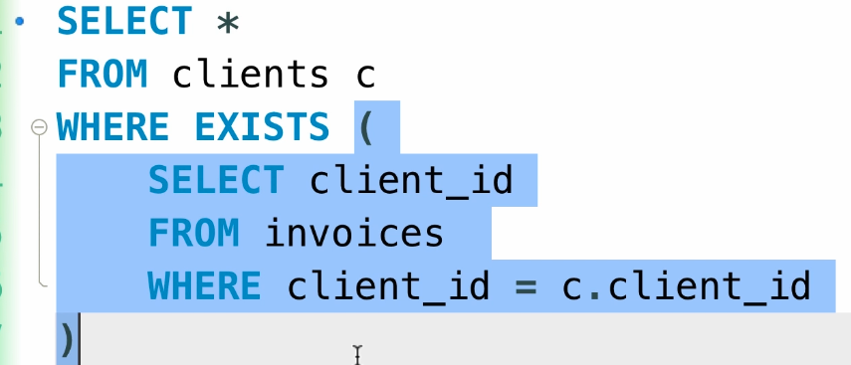

Consider the following example:

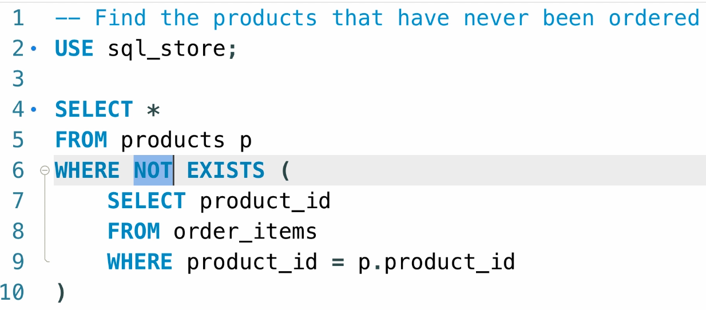

Here we have used the NOT EXISTS clause to make sure that we get the product that is not ordered.

**Subqueries in the SELECT Clause:**

We can also write the Subqueries in the SELECT clause to print the attribute by evaluating the subquery in the SELECT clause itself.

EG:

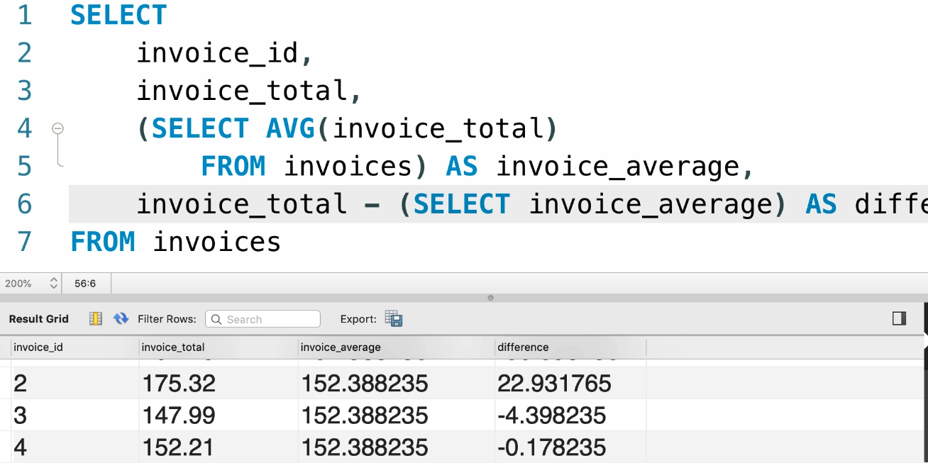

If you don’t get the required result by writing the casual subquery please use the corelated subquery.

**SUBQUERY in the FROM Clause:**

If we want to pass the already performed query to another query and then perform specific operations on the query then we can pass the query to the WHERE clause like this:

**We need to pass the Alias to the WHERE clause in the end irrespective of if we are going to use it or not.**

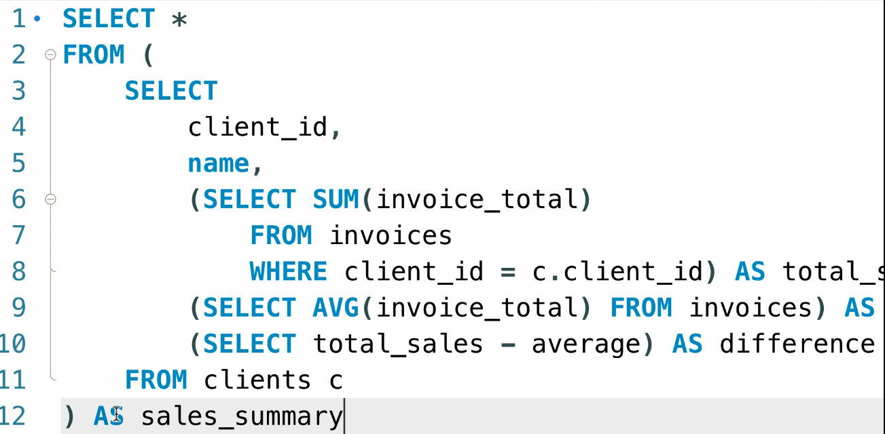

**Make sure to write this subqueries for the simple queries or else it might increase the complexity of your code.**

**Numeric Functions:**

**ROUND() :** We are going to round off the number provided as an argument and optional parameter with the precision.

**TRUNCATE():** We are going to keep the digits and remove the ending numbers provided as an number in the argument. Eg: TRUNCATE(2.333,2) 🡪 2.3 (BY removing the last two digits)

**CEILING():** We will get the Round-off of the provided number.

**FLOOR():** We will get the round-down off the provided number.

**RAND():** We will generate the random number between 0 and 1

**STRING Functions:**

**LENGTH():** We will be getting the total characters of the given string.

**UPPER():** Converting the provided string to UPPERCASE.

**LOWER():** Converting the provided string to LOWERCASE.

FOR More info please use the GOOGLE DOCS.

**DATE FUNCTIONS:**

**NOW():** Current Date and Time.

**CURDATE() and CURTIME():** Extracting the current Date and Time.

Consider that we want to get the list of orders from the current Year without hardcoding the year value, we can use the following query:

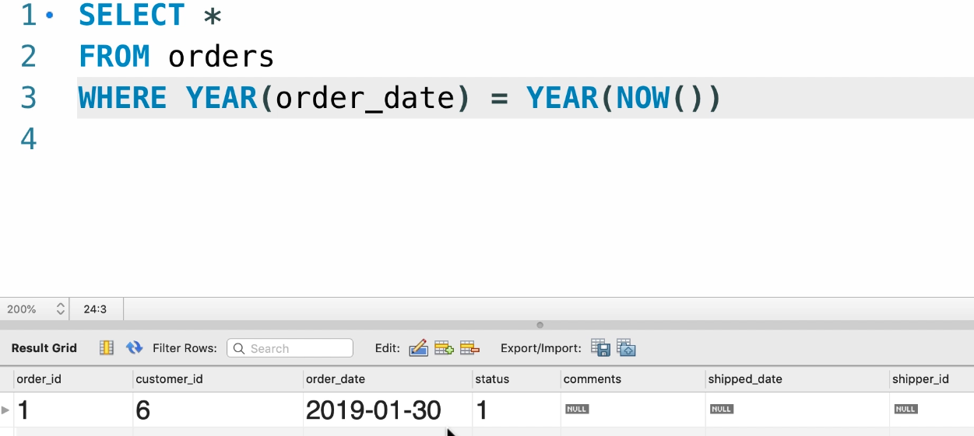

**Formatting Dates and Times:**

We can format the dates as per the format like this:

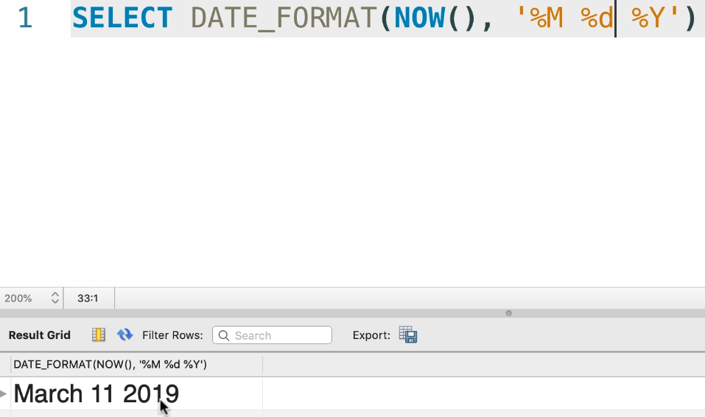

%Y 🡪 Year in 4 digits

%y 🡪 year in 2 digits

%m 🡪 month in numbers

%M 🡪 Month in name

SQL Server Date time format:

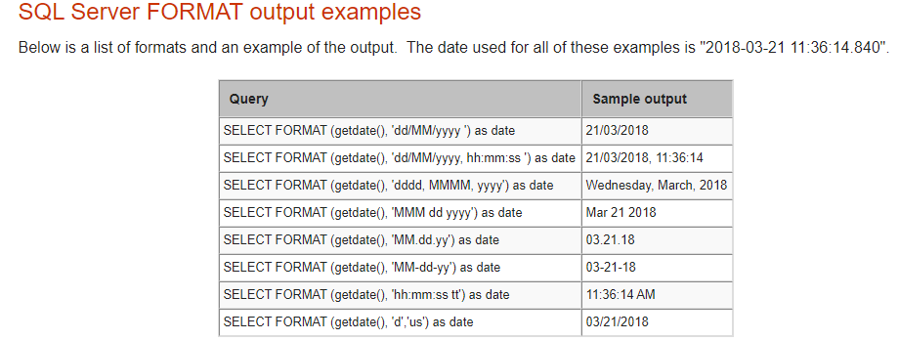

**Calculating Dates and Times:**

Manipulating the dates, that is adding an year to the current date can be done by:

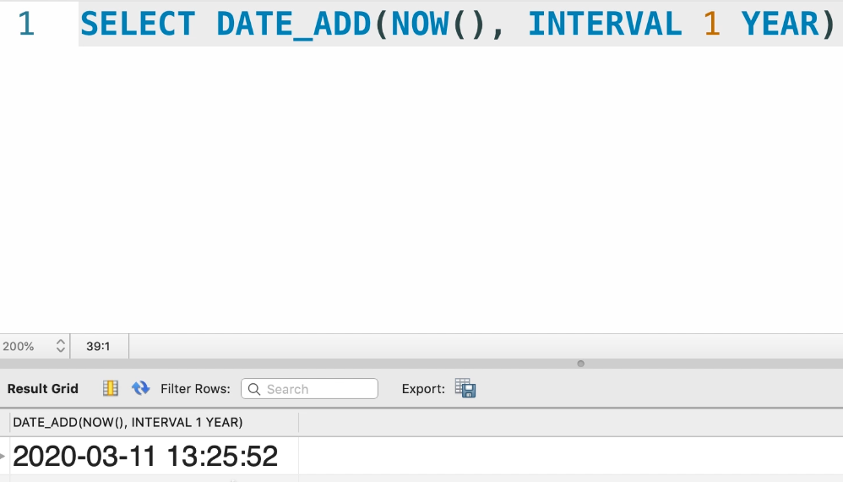

Suppose, we want to perform the date differences:

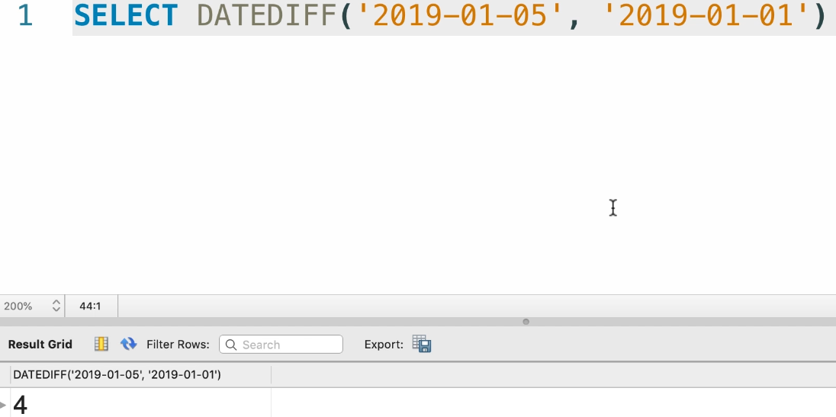

**IFNULL and COALESCE functions:**

If there are any NULL entries in the Table, then we will be replacing the NULL text with the manual text from our end.

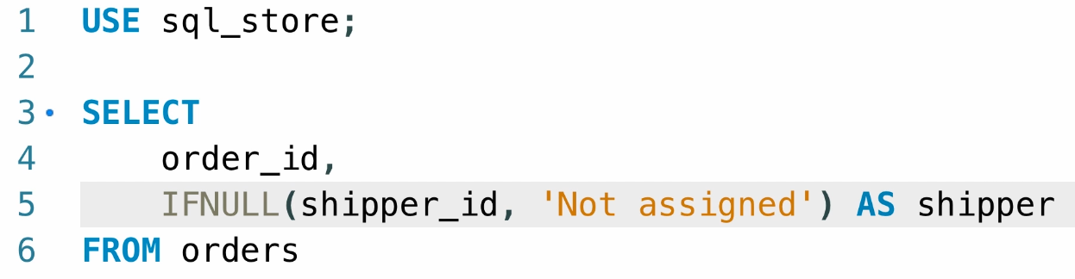

Now by using the COALESCE function, we will be passing the set of parameters and the first non-NULL value will be returned.

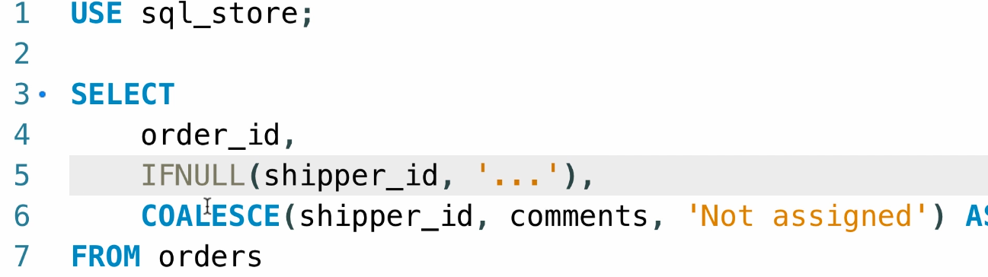

Here we get the value from Comments first, if it is NULL then we get the value called as “Not assigned”.

**IF function:**

Consider an example of classifying the invoice as active or archived based on the year using the IF statement:

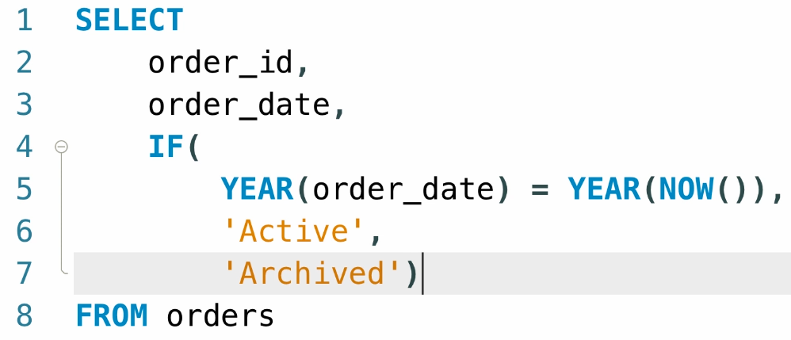

Another exercise on the If statement:

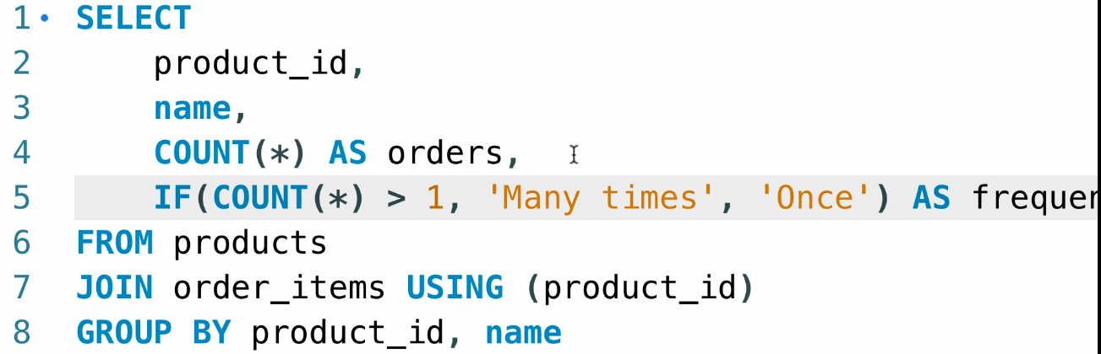

We will be getting the count of the orders and printing the appropriate message based on the frequency.

**CASE Operator:**

Suppose we have many if cases, then we can use the CASE operator:

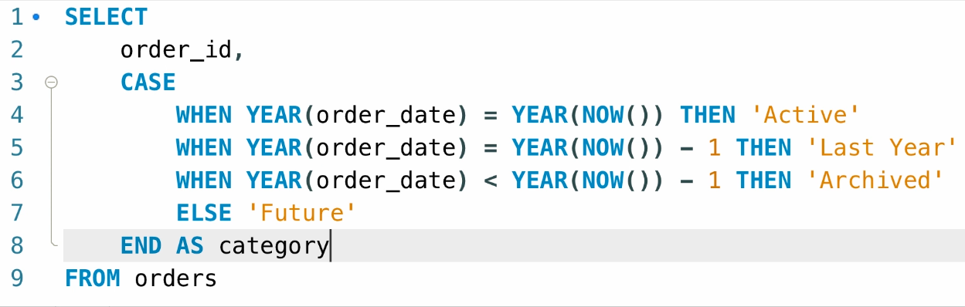

Now we have another exercise for printing the category based upon the points:

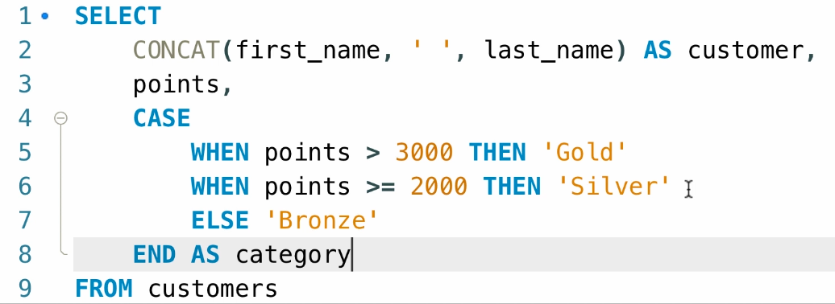

**Creating Views:**

Whenever the Queries get complex, we can save the subqueries in a view and then we can reuse the code whenever required.

Consider the following query :

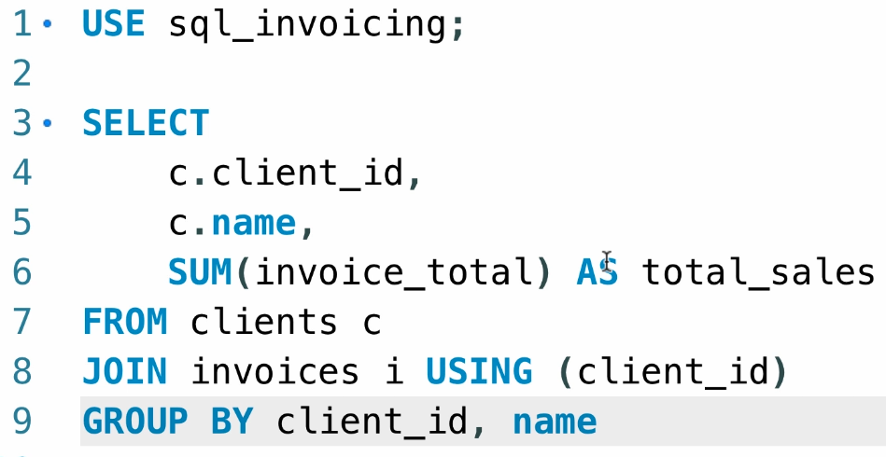

We can create a view and store this query in a view and reuse it whenever required like this:

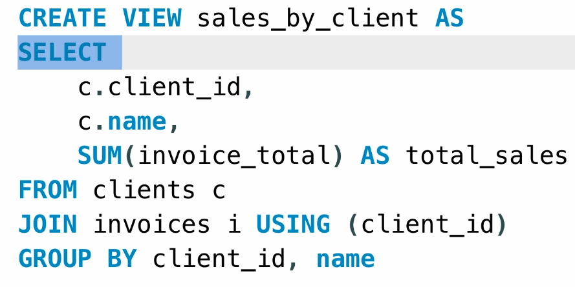

We can perform all the SQL operations by using this view:

Eg: SELECT * from sales_by_client 🡪 this will select all the data stored in the view.

**Remember: The data is stored inside the table itself, not in view, so views acts as a virtual table.**

**Altering or dropping views:**

We can recreate the view by Dropping the view and then executing the create view statement once again.

We can use the REPLACE keyword and then recreate the view like this:

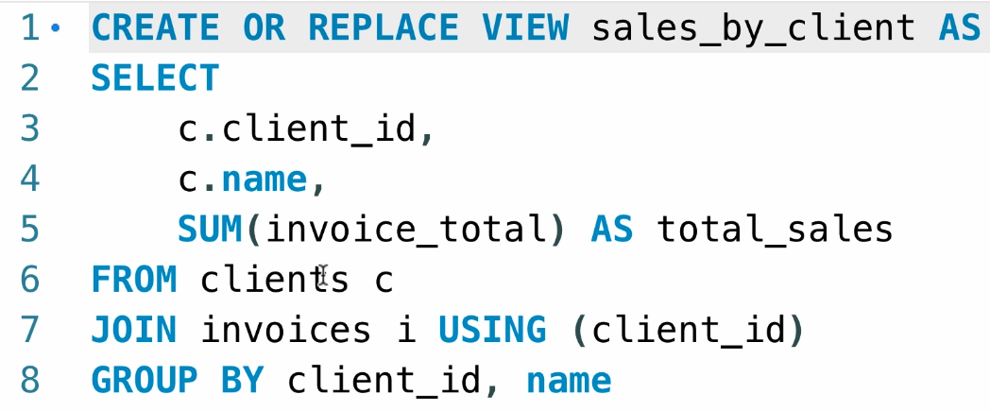

We can also save the view files under the source control and then publish it over the git so that other users can also make use of this view.

**Updatable views:**

To update the views, the following conditions must satisfy:

1. DISTINCT keyword mustn’t be present.
2. Aggregate functions must not be used.
3. GROUP BY/ HAVING clause must not be used.
4. UNIONS must also not be used.

We will be writing a general query that will take the attributes from the invoices table and then calculate the balance like this:

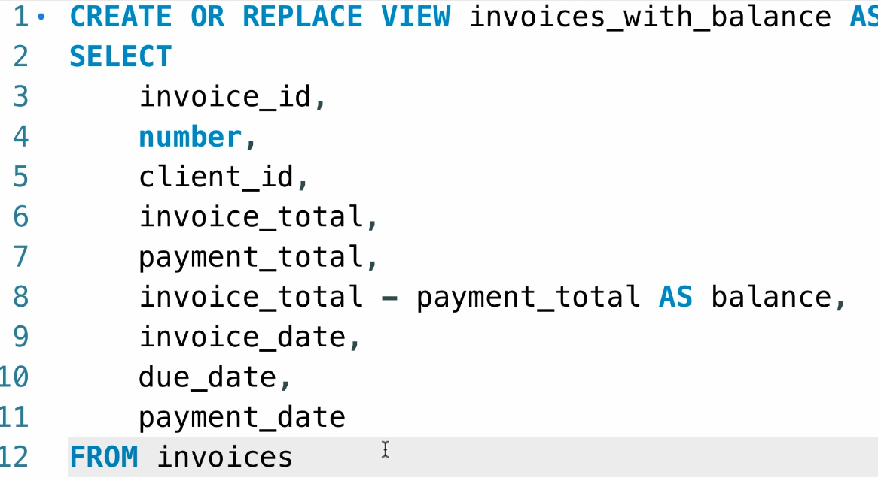

WHERE (invoice_total-payment_total) >0

Now as we have satisfied all the conditions for the UPDATABLE query, now we can pass a delete query to this statement.

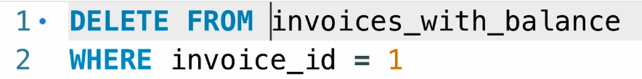

We can also pass the UPDATE statement to this view and add the date like this:

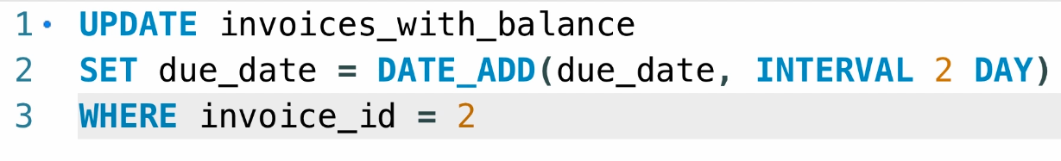

**WITH option CHECK clause:**

This will not allow the INSERT, UPDATE statement to exclude the rows in the table.

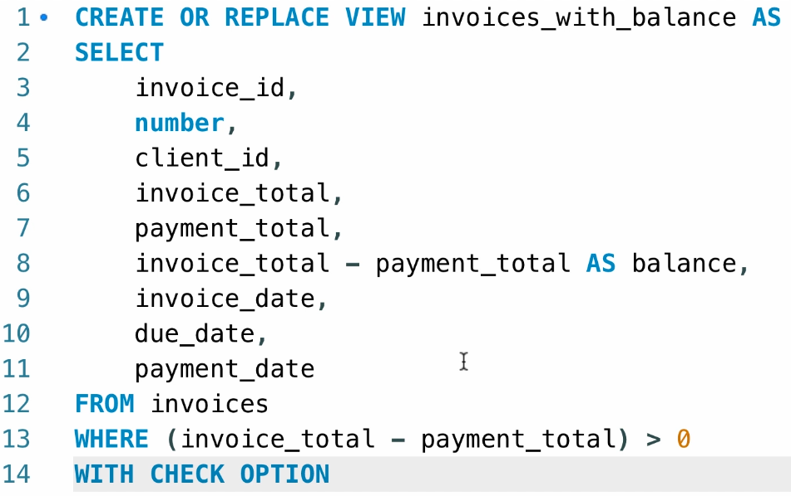

**Other benefits of view:**

1. Simplification of queries.
2. Reduces the impact of change
3. Restricts access to the data.

**Stored Procedures:**

We shouldn’t write the SQL queries inside the programming logic in the application, that makes the code messy and re-compilation is needed.

So to avoid this mess, we will be using the STORED PROCEDURES to store the SQL queries independent of the application code.

Benefits of using the Stored procedures:

1. Storing and organising the SQL.
2. Faster execution.
3. Data security.

**Creating a stored procedure:**

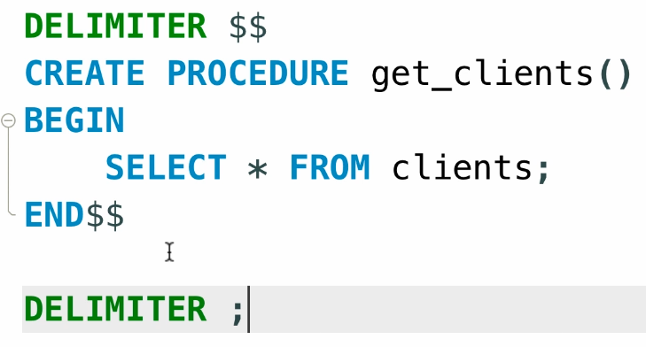

The statement inside the BEGIN and END is called the BODY of the procedure and then we will be changing the default DELIMITER in case of adding the complete procedure as a single code.

By conventions, the **“$$”** is used as a default delimiter by developers, so we will be using that to add this code as a single piece of code and then changing it back to normal after the executions are done.

We will be calling the STORED PROCEDURE using the



**Creating SQL using MYSQLWORKBENCH:**

We can click on the SETTINGS icon attached with STORED PROCEDURES and write the required procedure and then click on Apply to create a stored procedure using the SQLWORKBENCH.

We can drop the PROCEDURE using the :



**Parameters:**

We can use the parameters to send the value to the procedures.

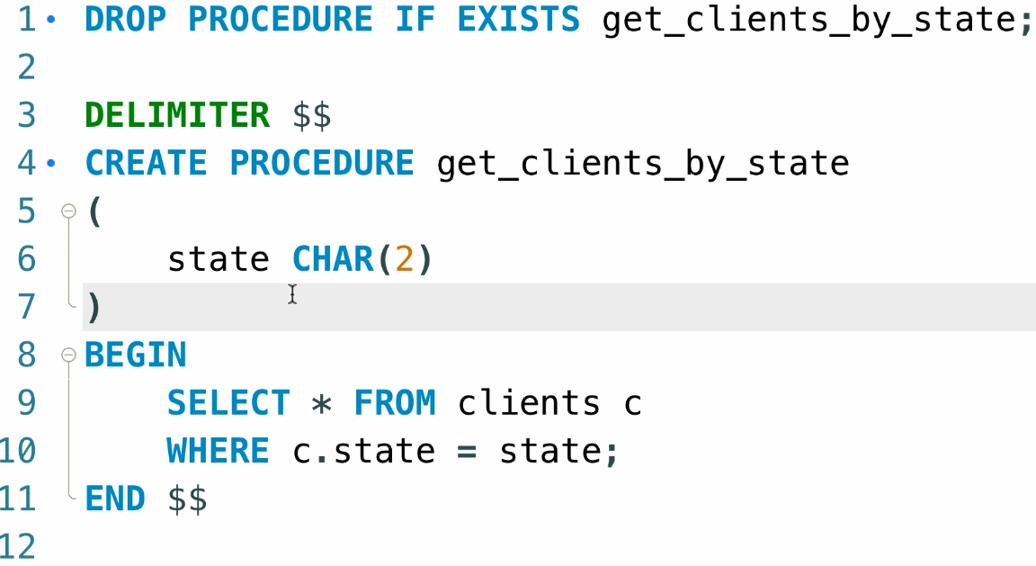

We will be passing the parameter name and followed by the DATATYPE.

We can call the procedure by using the CALL like this:



**Parameters with default value:**

Suppose, if the parameters were not passed to the PROCEDURES, then we need to make sure that a default PARAMETER is taken to call the procedure like this:

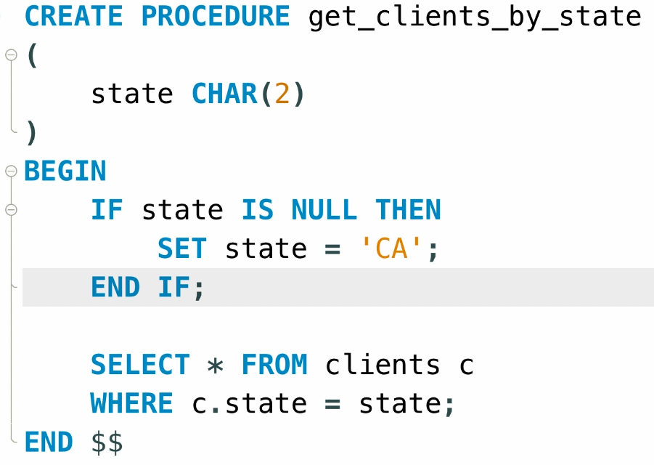

We can also use the IFNULL Clause to reduce the complexity of the code:

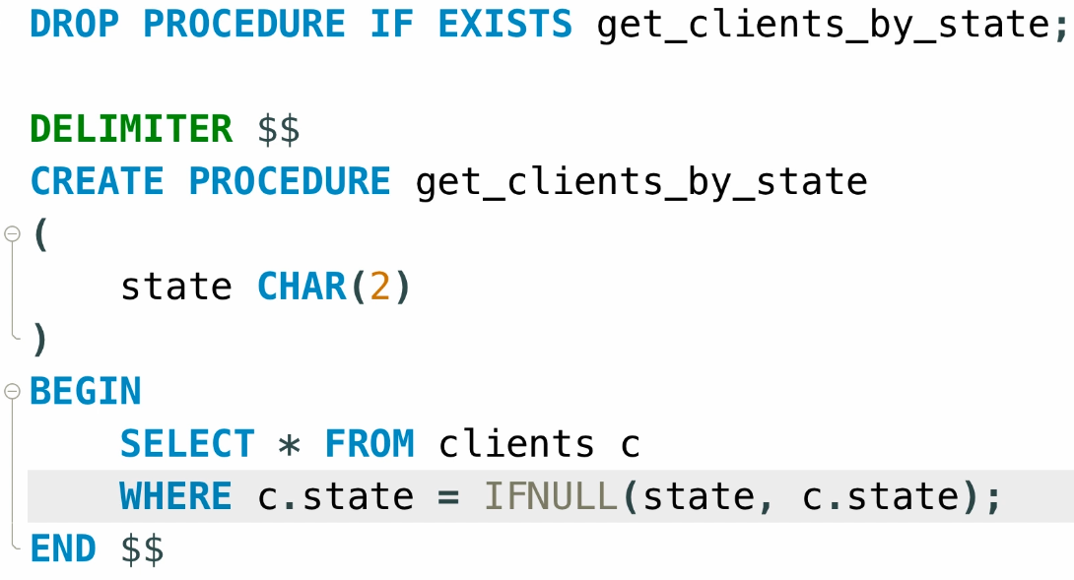

**Parameter Validation:**

Consider this query:

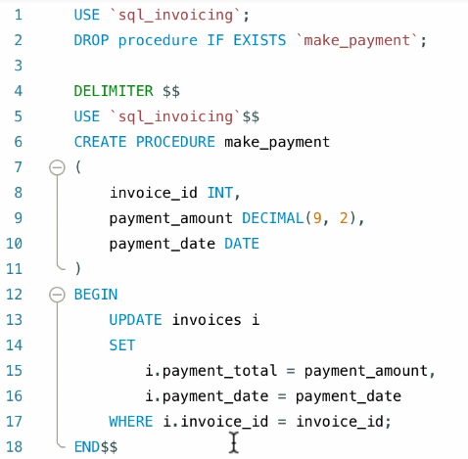

Suppose, we enter the negative value for the Payment_amount and then it gets stored in the DB without any issues,

To overcome that, we need to validate the data before processing with the UPDATE operation.

It can be done by like this:

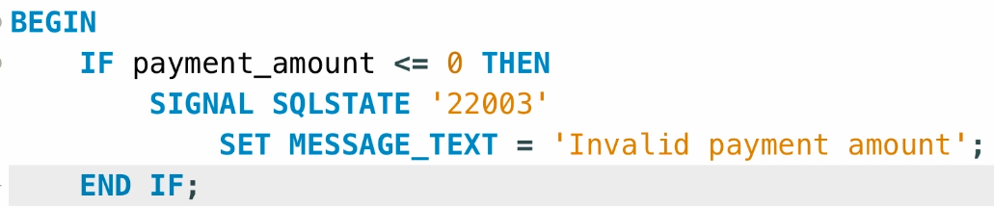

We will be checking the number format before proceeding with the UPDATION, SIGNAL SQLSTATE is used to raise an exception for the user and 22003 stands for the error code for “OUT OF RANGE values”.

We can even set the friendly message by using:

SET MESSAGE_TEXT followed by the message in the quotes.

**Output Parameters:**

We need to make use of OUT clause to make sure that input parameters work even outside of the PROCEDURES.

We can also use the Variable declaration method to set the output parameters:

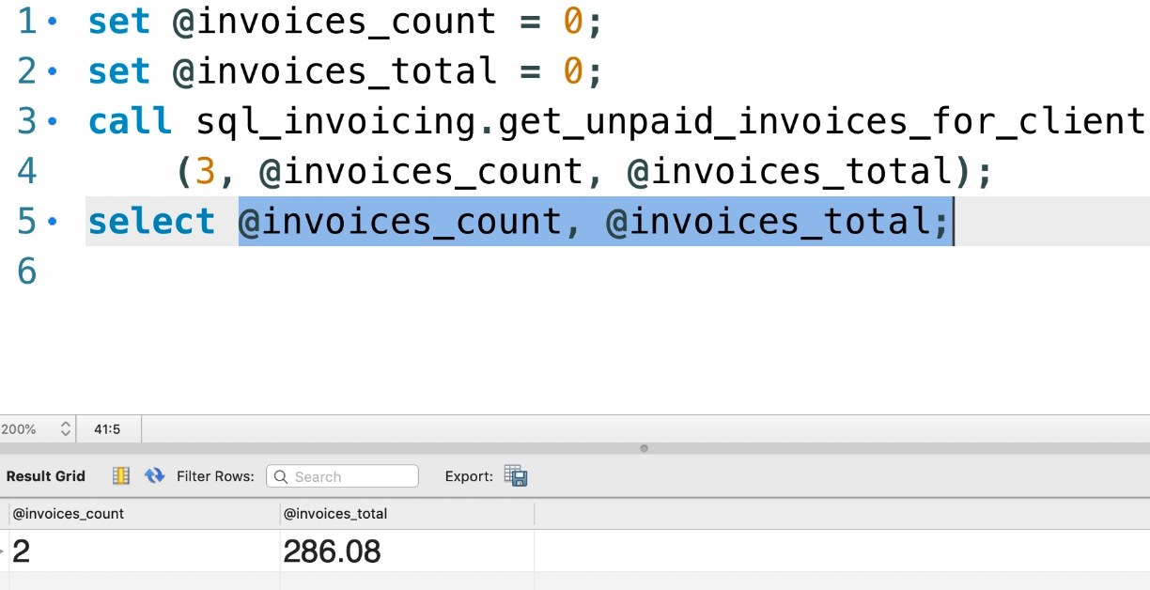

**Variables:**

The variables defined using the SET statement are called as SESSION variables, they remain active until the user disconnects from the SQL.

Local Variables stay active until the procedure gets executed, after that they are lost.

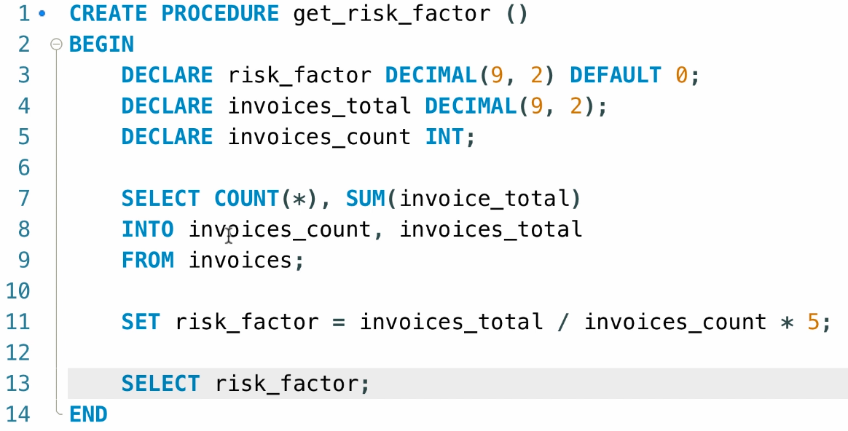

**Functions:**

Functions are similar to Procedures but they are used to return single value only, not the entire row/ columns.

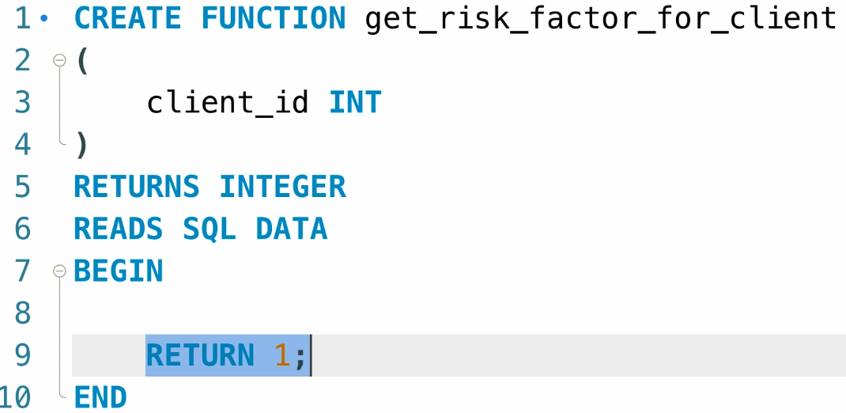

Now we will be copying the data for calculation and pasting it inside the BEGIN clause.

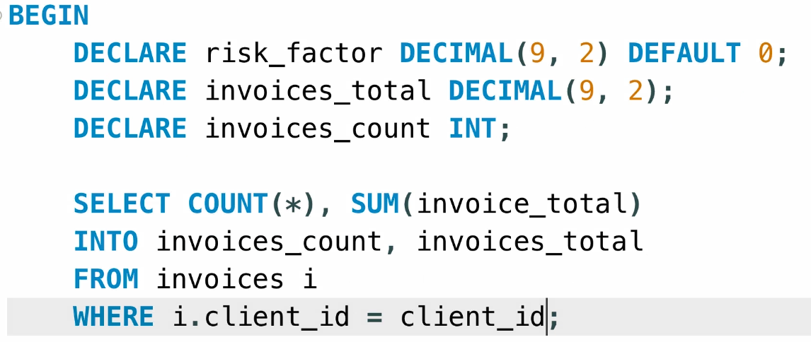

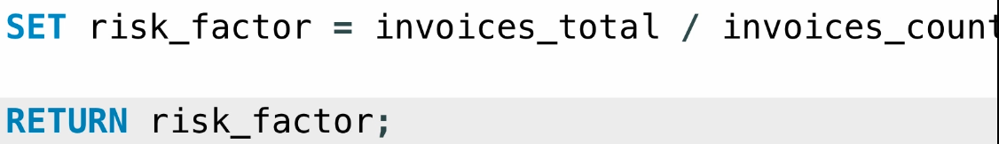

We can call the function by using:

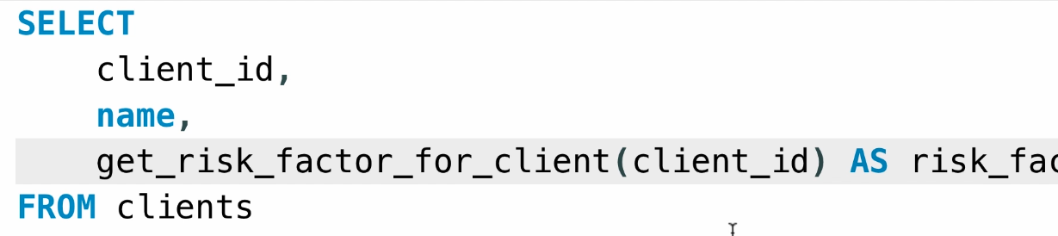

**Triggers:**

It is a block of code that gets executed before or after an INSERT, UPDATE or DELETE Statement.

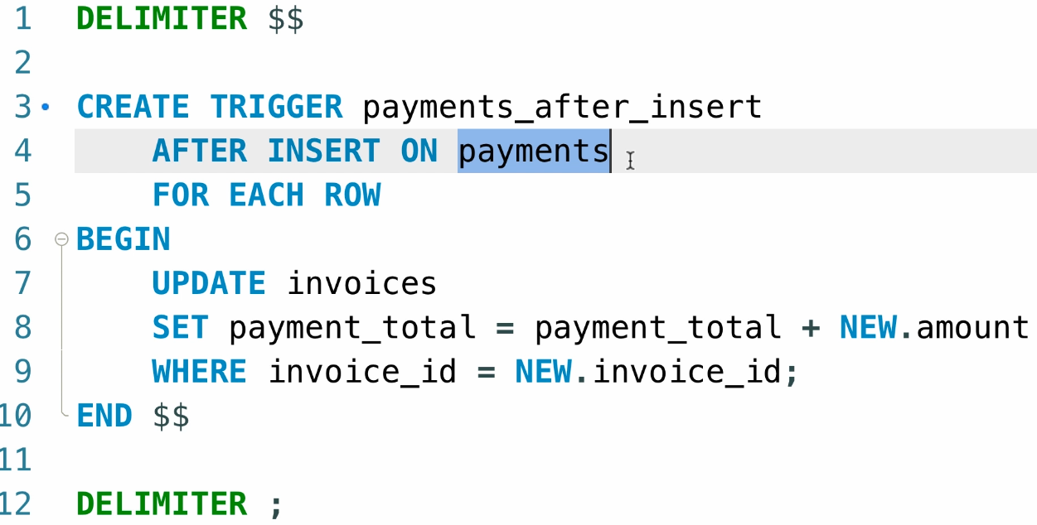

After the INSERT statement is executed for the payments table, then this trigger gets executed and the payment_total will be updated.

We will now try to insert the data onto the payments table and then the total must get updated automatically now:

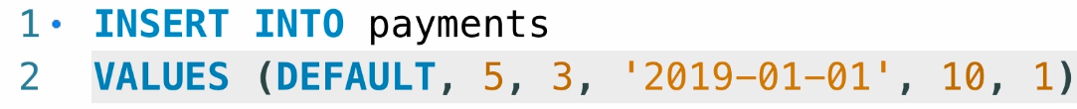

Following trigger is for the execution after the DELETE statement:

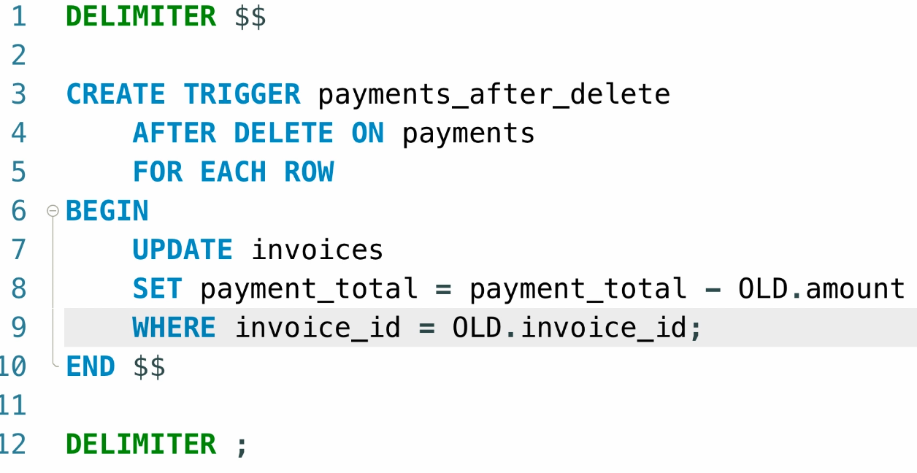

And we execute the DELETE statement here:

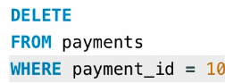

And we see that the payment_total now reduces back automatically.

**Viewing Triggers:**

We can view the triggers by using the SHOW TRIGGERS command.

**Dropping Triggers:**

We can drop the triggers by using:



We can ideally use this at the creation of triggers.

**Using Triggers for Auditing:**

We can create a log for the changes being made in the DATABASE and view it later whenever required.

First we shall create a table to store the audit values:

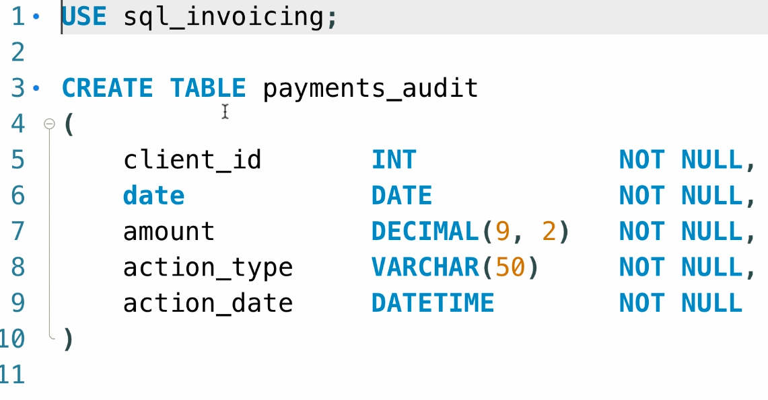

Consider the old payments_after_insert trigger, we will be adding another trigger inside it to log the insertions into the payments_audit table:



Similarly for the deleted entries, we will be using the same audit lines but will be replacing the NEW with OLD and then ‘Insert’ with ‘Delete’

**Events:**

A task or block of code that gets executed according to a schedule.

Type “**SHOW VARIABLES**” to get list of all system variables.

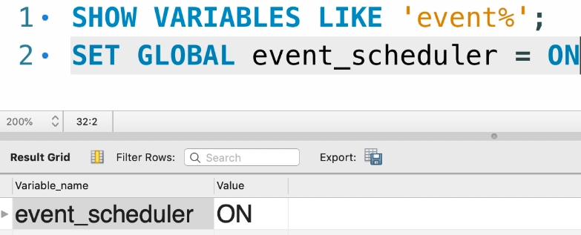

We need to set the event scheduler variable ON to schedule our own variables.

A sample code for creating the events:

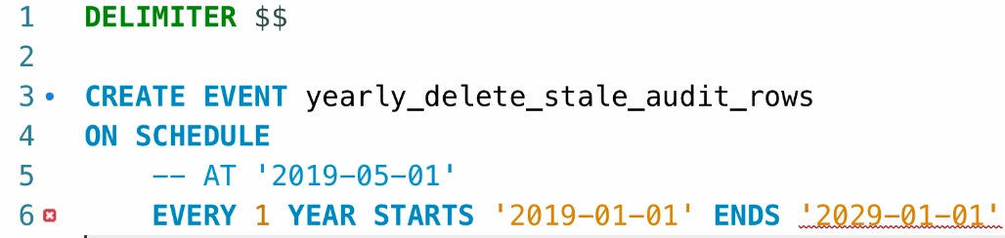

The following code is used to delete the Payment Audits every year repeatedly:

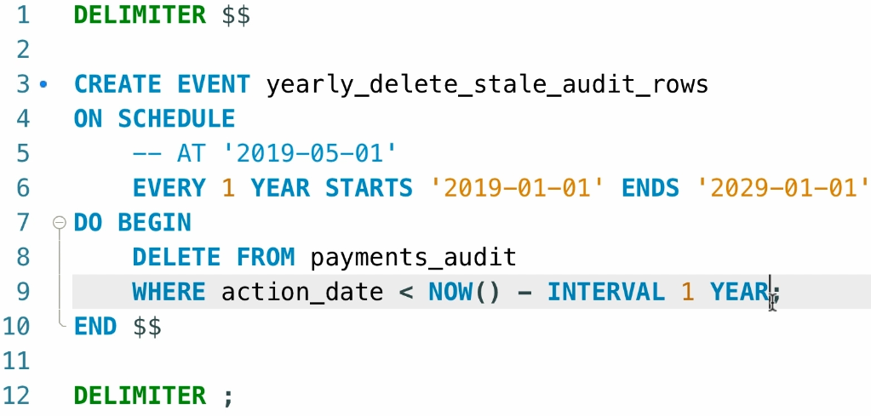

**Viewing and Dropping Events:**

We can view events using the “**SHOW EVENTS**” query.

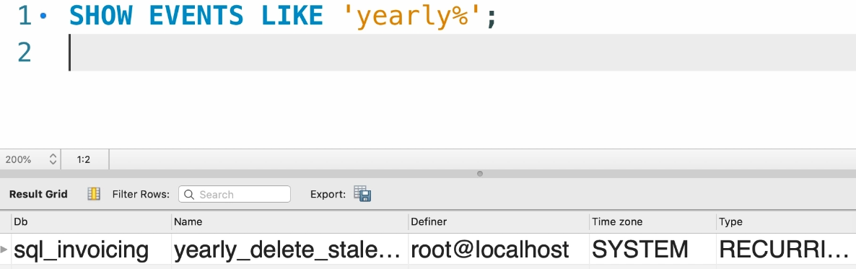

For dropping the events, we use “**DROP EVENT**” or more conventionally “**DROP EVENT IF EXISTS**” followed by the event name.



We have another better alternative for deleting and inserting the new events, we can use the “**ALTER EVENT**” keyword to make the specified changes, it can be done by using:

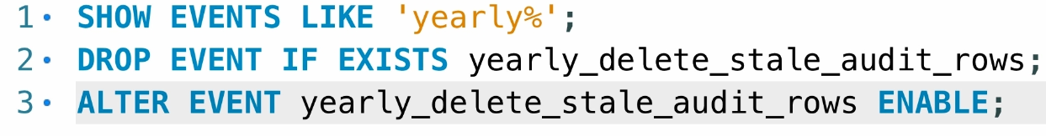

We can make sure that only selected events get affected by this, we can use the ENABLE / DISABLE keyword after the ALTER KEYWORD.

**Transactions:**

A group of SQL code or statements that represent the single unit of work.

Consider an example, we are sending the money to friends, we need to face two types of operations:

1. Debit
2. Credit.

In order for the transactions to work, we need to make sure that both of these operations are done successfully, if any one of them fails then the whole operation will be rolled back to the previous state.

Consider another snip:

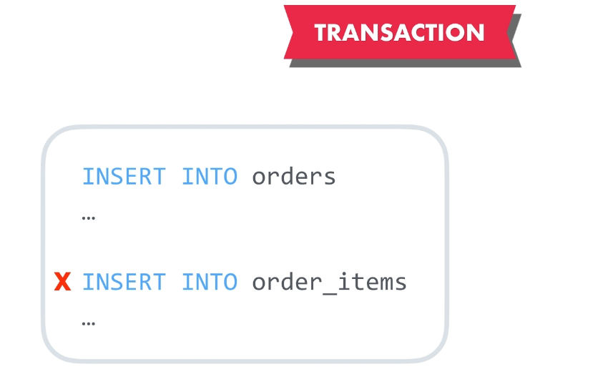

Both of the statements need to be executed to make sure this transaction is done, or else the process will be rolled back.

**ACID Properties:**

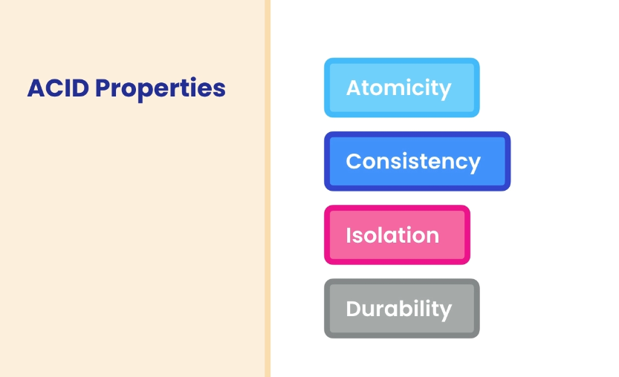

The above snip identifies the various ACID properties of the transaction:

1. **Atomicity:** Each single unit of work must be completed to make sure that the transaction is completed.
2. **Consistency:** Transactions always happen in consistent manner.
3. **Isolation:** Transactions will be kept in isolation from each other due to security purposes.
4. **Durability:** Changes made from transactions are permanent and we will always have changes whenever required.

**Creating Transactions:**

Transaction must begin with **START TRANSACTION** and end with **COMMIT.**

The lines written inside will be unit of work and if any of them fails, then changes are rolled back to the previous state.

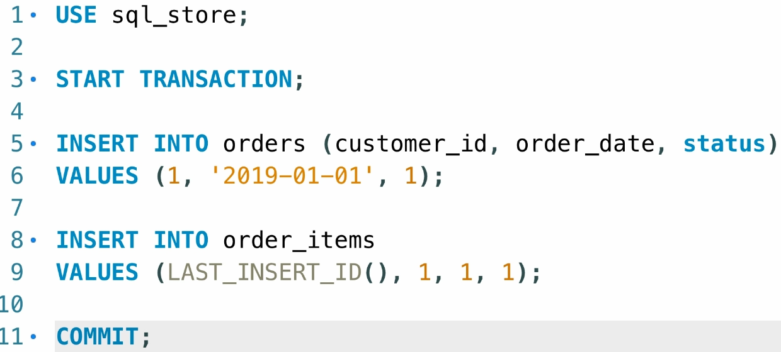

MYSQL will automatically wrap up the INSERT, UPDATE, DELETE operations inside the transactions and commits changes.

This is done by using the AUTOCOMMIT system variable.

**Concurrency and Locking:**

When multiple users are trying to access the data in the database it is called as concurrency. When some user modifies the data the others users are accessing, it may become a problem for other users, we will see how MYSQL will handle this:

Consider this code being executed by the multiple connections in the MYSQL:

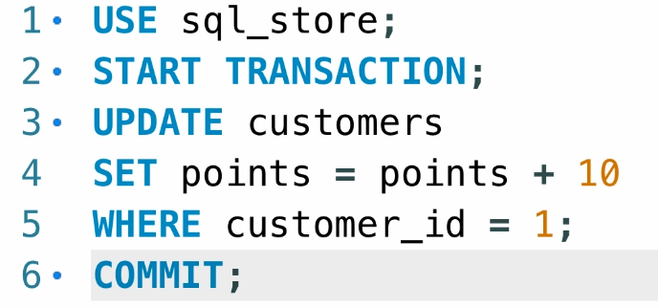

1. Execute the query line by line, and then stop after the UPDATE statement for first connection.
2. Now go to another connection, do the same execution line by line and then after you execute the UPDATE statement, you will see that the query will wait for something to happen.

This is because, the query is waiting for the previous UPDATE to be COMMITED or ROLLED BACK.

Because the SQL Manager software has put a lock on first query to finish the execution and then pass the power to the second query.

We can override the default behaviour of our LOCK to resolve the concurrency problems if required.

**Concurrency problems:**

1. **Lost updates:**

Two or more connections try to update the same data without the LOCK and then the latest connection update will override all the changes taken place on the update.

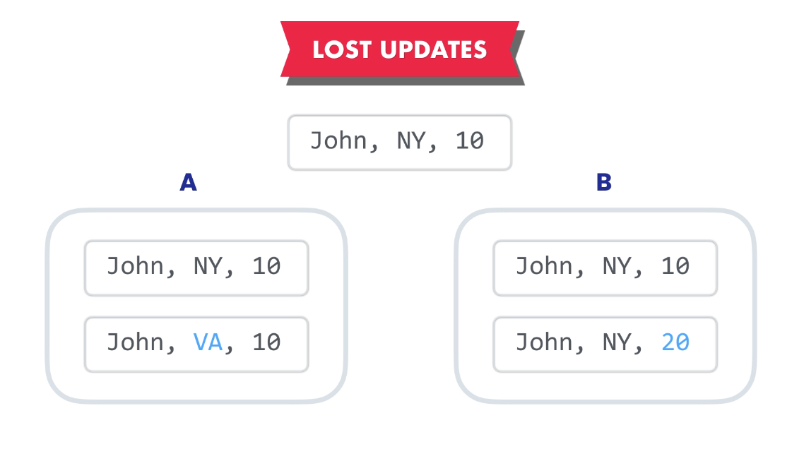

To overcome them, we need to use LOCK where the first transaction gets completed and then followed by the next after the commit of first transaction.

1. **Dirty Reads:**

When a transaction reads the data before the data is being committed and makes a decision on this less useful data is called as Dirty Reads.

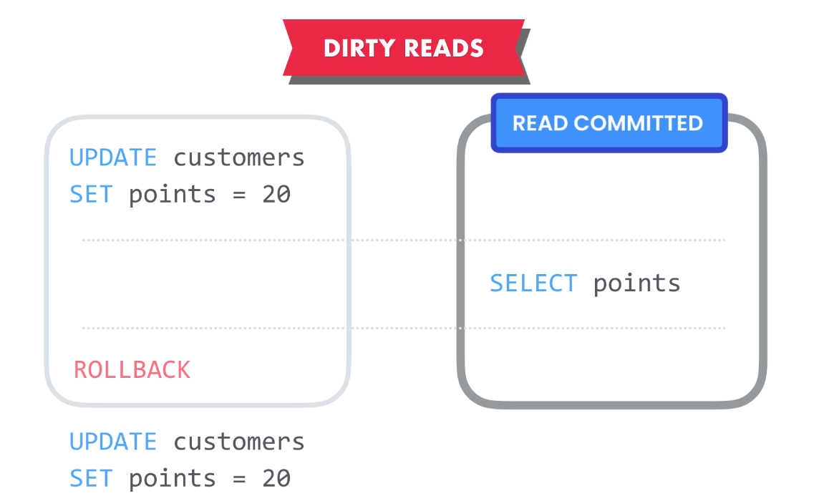

The solution is to include the TRANSACTION ISOLATION between these transactions, We will make sure that only the committed data is being read by the second transaction to avoid such issues later.

The transaction isolation level will be “**READ COMMITTED**” 🡪 Read only committed transaction.

1. **Non repeating reads:**

During the course of the transaction, we read the values repeatedly using the SELECT statement and we get two different results when reading the data.

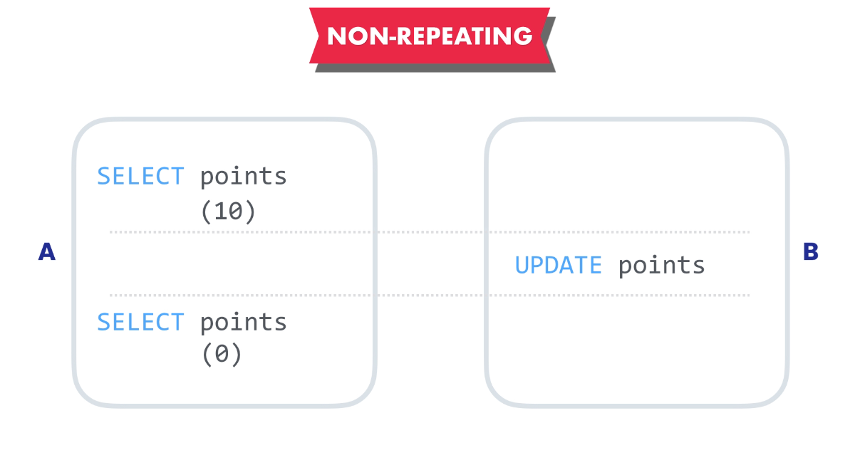

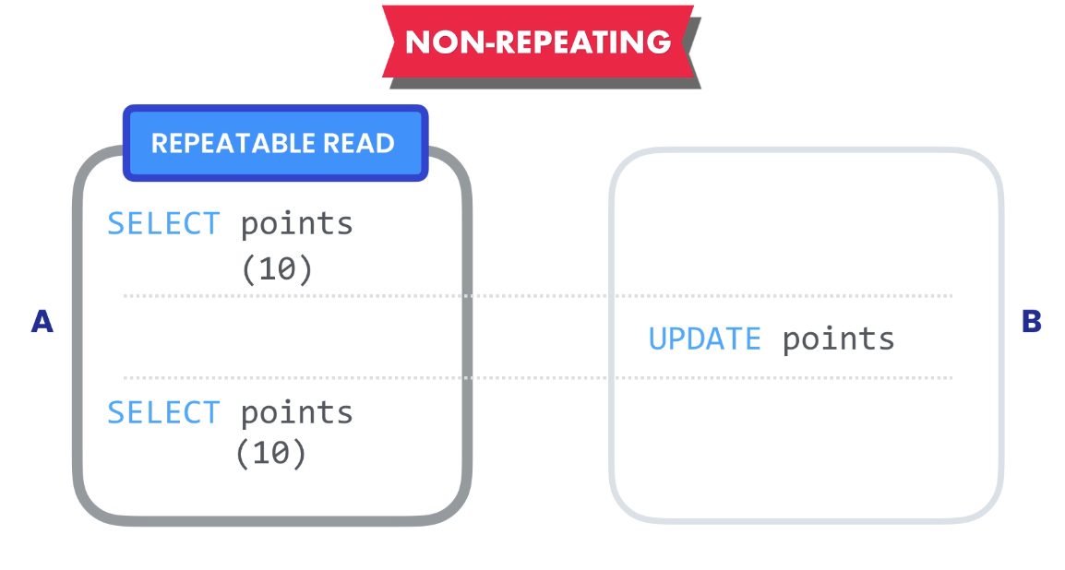

We can use the Transaction Isolation named “REPEATABLE READ” to make sure that our data remains consistent even though after repeatable reads.

1. **Phantom Reads:**

The data that gets added, deleted unwantedly during the occurrence of the multiple transaction is called as Phantom Data.

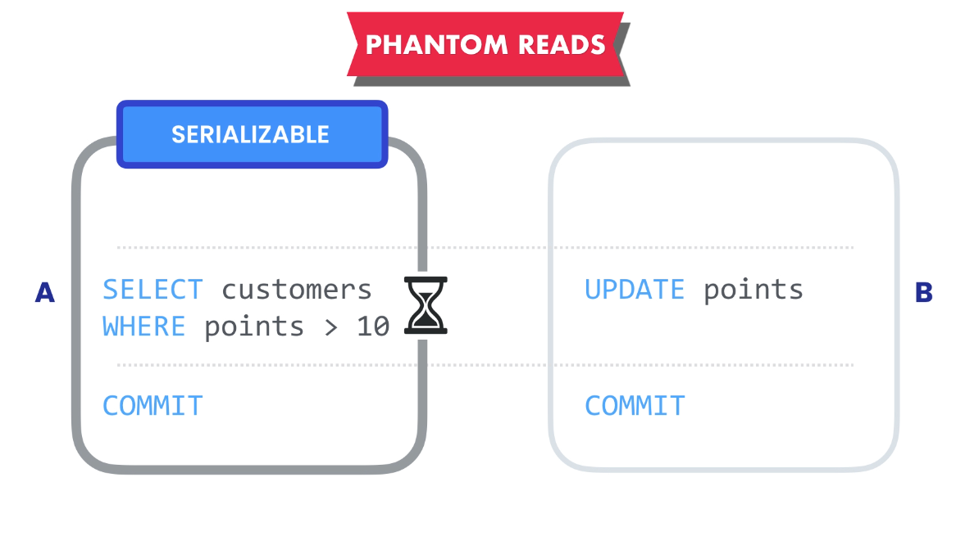

Our transaction needs to be aware of the changes and has to wait for the other transaction to COMMIT and then perform its execution to make sure there are no phantom data.

**Transaction Isolation Levels:**

The default level of isolation used by the MYSQL is: REPEATABLE READ.

Below are the list of isolation levels and the concurrency problems:

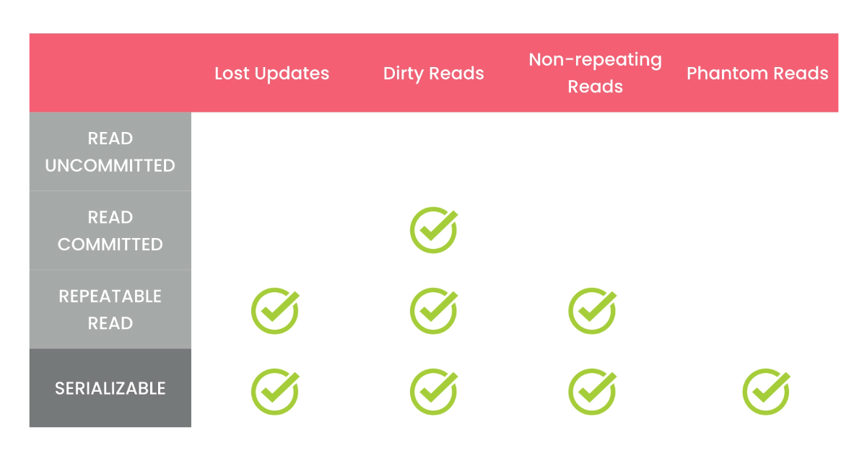

The SERIALIZABLE is the highest level of isolation and READ UNCOMMITTED is the lowest level of isolation.

The Higher the level of isolation, the more restricted will be the concurrency and more the resources will be consumed by the system and vice versa.

We can view the transaction isolation set by the system using:

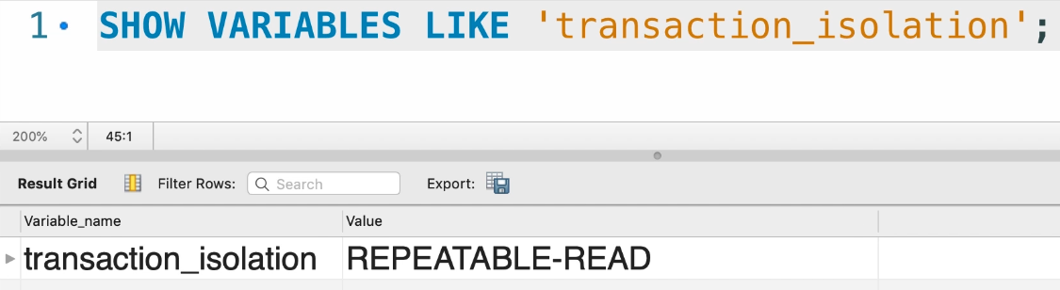

We can set the level of isolation using:

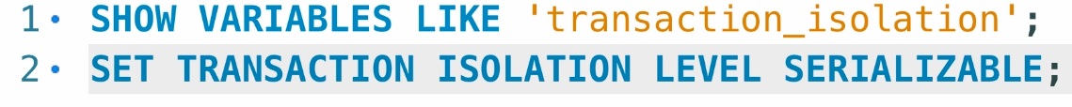

**READ UNCOMMITTED ISOLATION:**

1. Open two connections
2. In the first connection, write the following code:

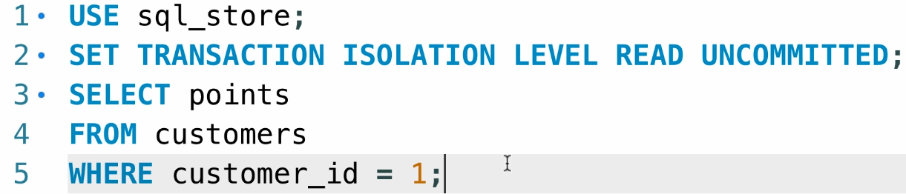

1. In the second connection, write the following code:

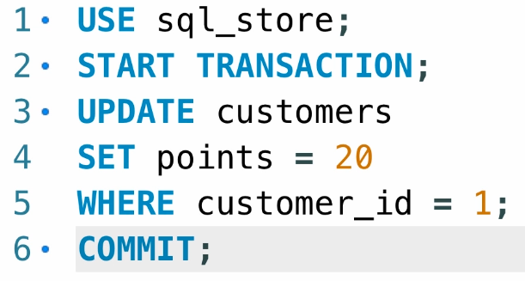

1. Execute the first connection query line by line and then go to second connection query and execute it line by line until the UPDATE and don’t execute the COMMIT line.
2. Back to first query, execute it, you will get this data:

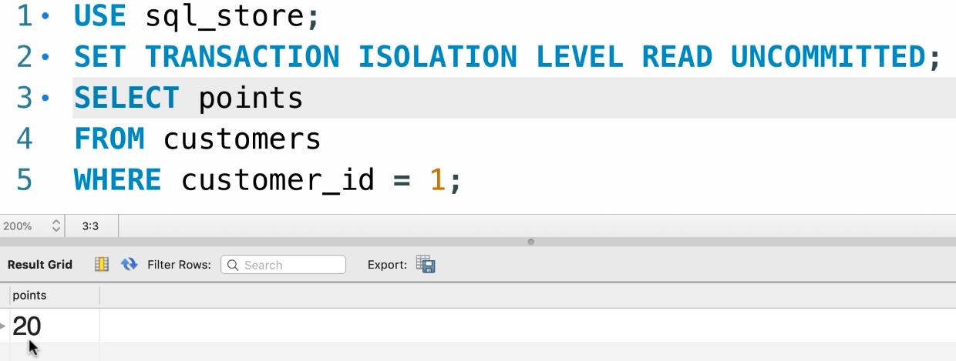

1. Assume that the second connection crashed and the transaction got rolled back, now the first query is dealing with the data that is never present. This is the problem with Dirty Reads.

**READ COMMITTED:**

1. Change the isolation level to READ COMMITTED in first connection first query.

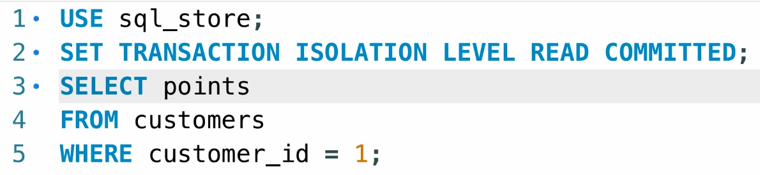

1. Execute that line of setting the isolation in first query.
2. Navigate to the second query in second connection, execute the line by line and then update the data.
3. Without committing the data, if we come back to the first query and select the data, we must get the previous data.
4. Add the commit line to the second query and execute the commit, now we must get the updated value.

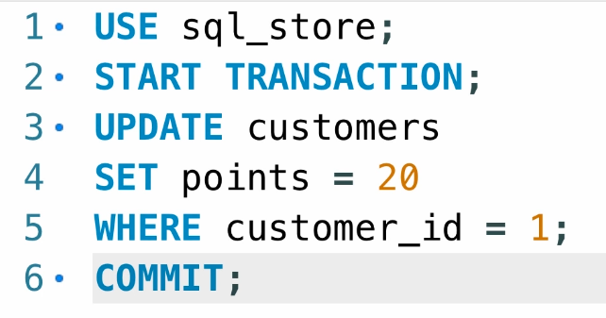

1. Now we will be having the problem with REPEATED READS, to get the inconsistent output, make this changes for first query:

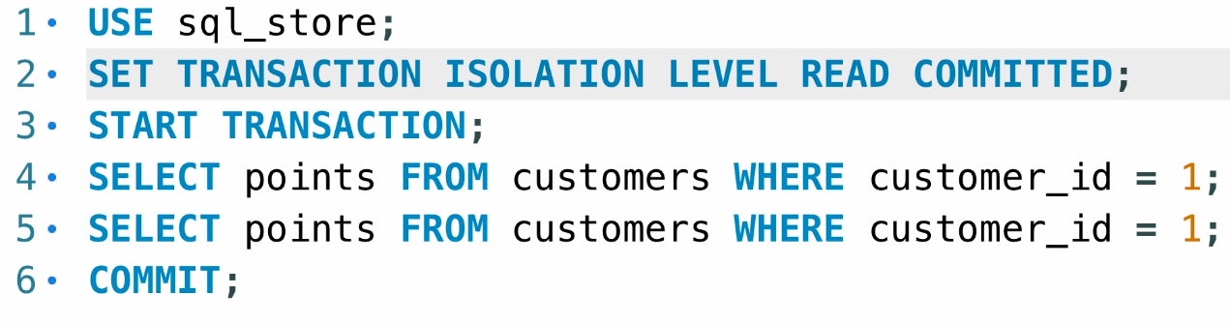

1. Now go to second query and update the points to 30 and then execute the second SELECT statement back here. We get inconsistent output.

**REPEATABLE READ:**

1. Make the changes in the isolation level:

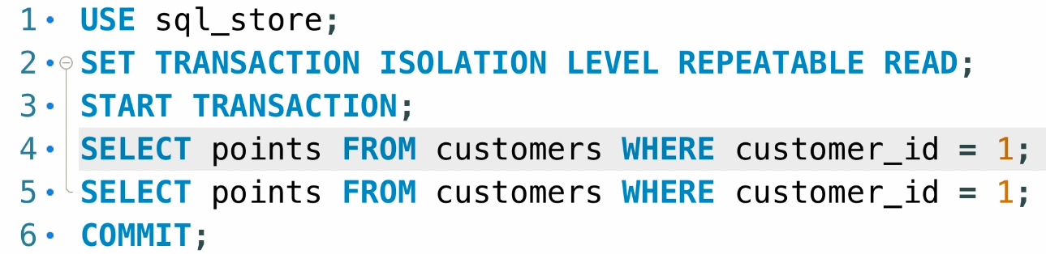

1. Now go back to the second query and make some changes to the values set, now we should see no changes in the output.
2. This is the default ISOLATION LEVEL.
3. Now we will face the problem with Phantom reads, so we will modify the first query to get the customers located in Virginia by:

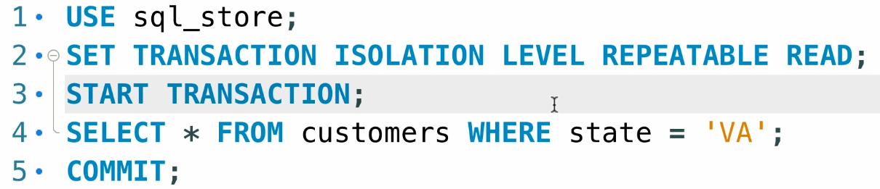

1. Change the second query to update the STATE to VA for first customer, we will miss the data of the required person after the commit. We will resolve it by using SERIALISABLE Isolation.

**SERIALISABLE Isolation:**

This is the highest level of isolation in the SQL.

1. Change the isolation level to the SERIALIZABLE isolation.

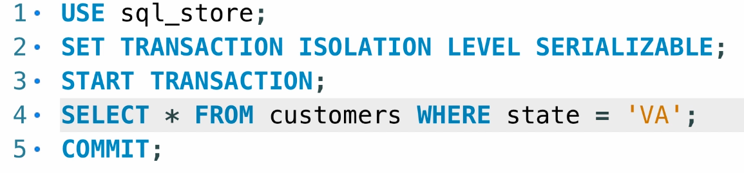

1. Now go to the second query in the second connection and then try to update the customer information and then commit the changes.
2. We will get the required results here in first query without any Phantom data or any other issues.
3. Beware to use this only for the Phantom read scenario, as this will consume up a lot of resources.

**Deadlocks:**

This happens when the two or more transactions holding the lock for another to complete and both of the transactions will continue to wait forever for the completion without success.

Consider the two queries for the execution:

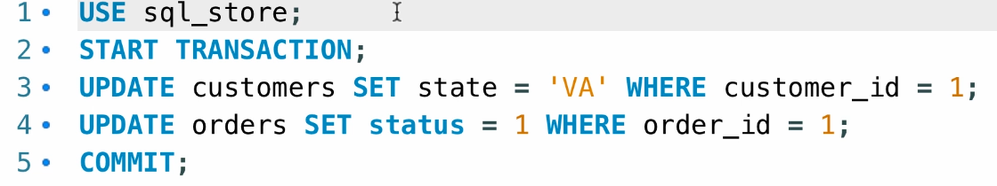

And

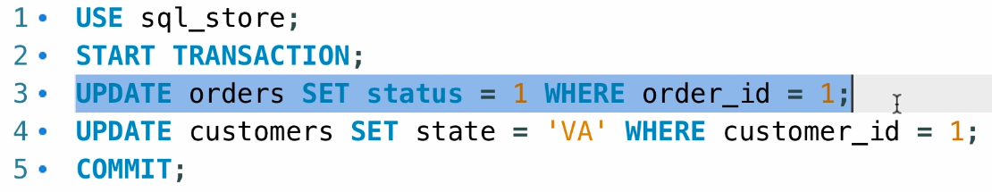

**Remember that: If there is a transaction working on a specified record, then it will be under a lock and it cannot be used under any other transactions.**

This above example is falling under deadlock because, as the first query first update statement is trying to work on the customers’ State and then it will be in LOCK until Commit.

The second query first UPDATE is working on the status of customers and will be under LOCK until commit.

Both remain in LOCK and continue to be as they are working on same records.

We can follow some steps to reduce the DEADLOCKS:

1. If an query is executed in its reverse order, it is most likely to cause the DEADLOCK, change the order.
2. Execute the query causing the DEADLOCK when users are not available.

**Indexes:**

Arranging the data in a manner such that locating the data becomes easy.

We can create the INDEX by using the CREATE INDEX keyword.

There are two types of indexes: Clustered and Non-Clustered.

**Clustered:** It determines the order in which data is stored in the table.

Eg: Clustered index on the specified column will cause the data to be ordered based on that column.

Indexing can be performed on multiple columns.

**NonClustered:** It creates the virtual index on the database engine for searching the items.

They require constant updates to be done as data is inserted and modified on the table.

**Creating and Dropping Index:**

We have a table that consists of EID and then followed by the NAMES in the columns,

We create a clustered index on the EID and then nonclustered index for the names.

We can create a clustered index by using:

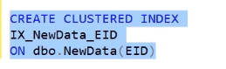

We will be creating a non-clustered index by using:

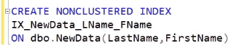

We can drop the indexes by using:

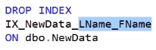

**DATABASE DESIGN:**

**String types:**

Following are the basic string types:

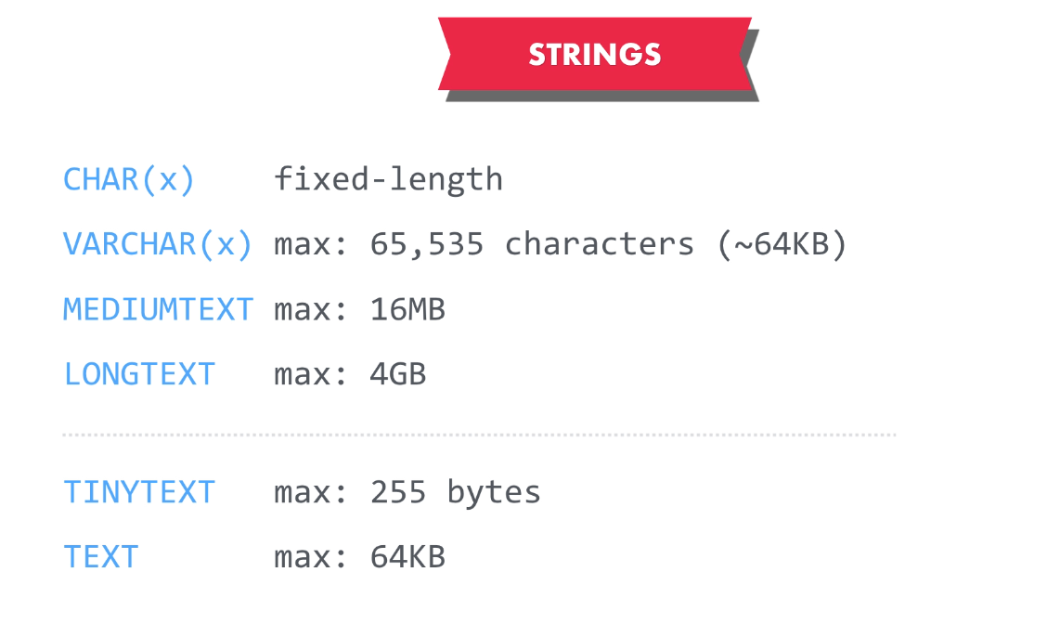

There is another type named nVARCHAR(x).

This will take 2 bytes of data, double to that of VARCHAR(x).

This can be used to store the UNICODE characters that is not possible from VARCHAR.

**Integer types:**

Following are the basic Integer types:

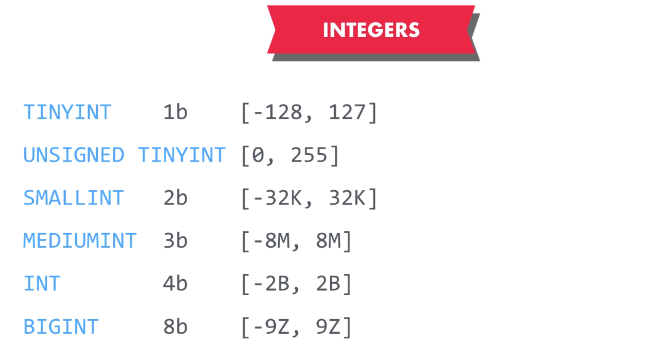

There is another type named “ZEROFILL” that helps to append the zeros to maintain the bytes size.

**Fixed Point and Floating Point Types:**

Following are some fixed and floating point types:

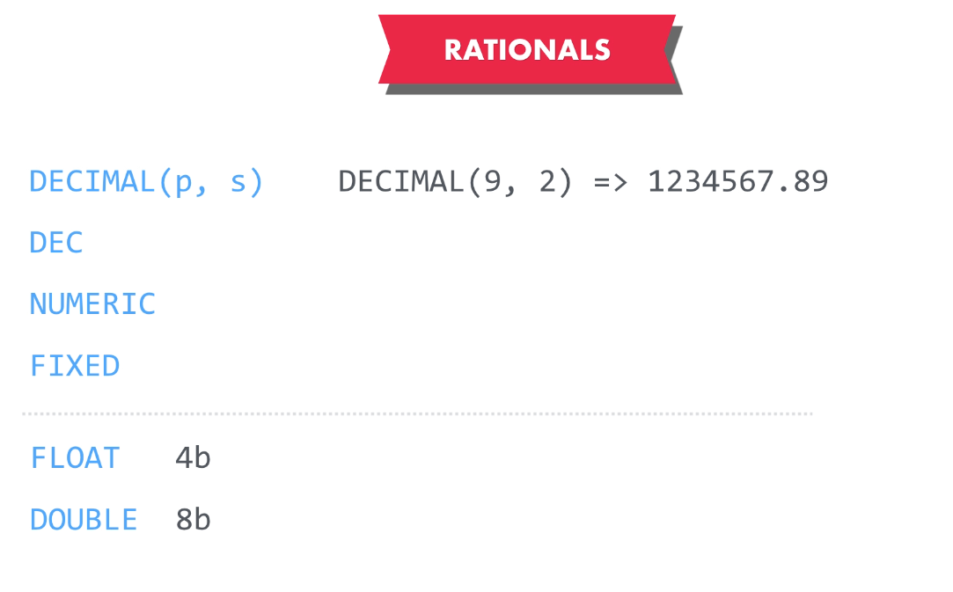

**Boolean Types:**

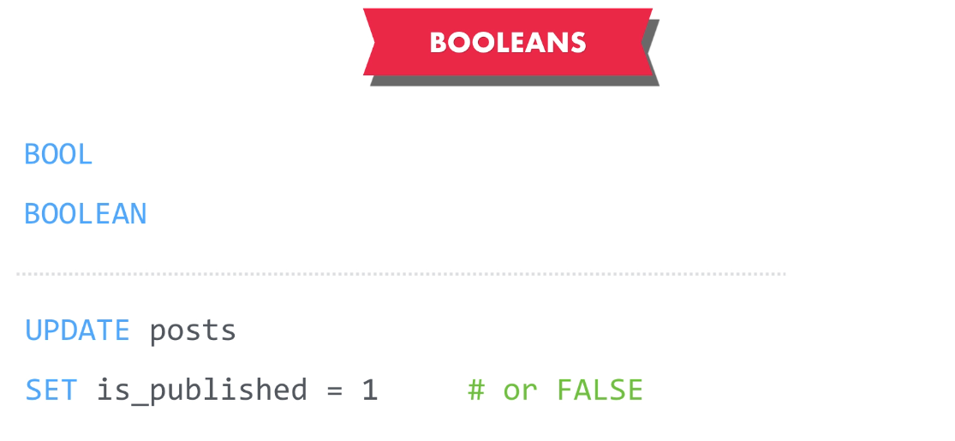

We can use TRUE OR FALSE as 1 OR 0, both work the same way.

**Enum and Set Types:**

Enum is used to restrict the types of values that can be accepted by the field in the table.

Eg: If we declare a SIZE column, we can restrict it to have these values only:

SIZE = ENUM(Small, Medium, Large)

SET are also used to pass the list of values to be accepted by the field in the table.

SIZE = SET (…values…)

**Date Time types:**

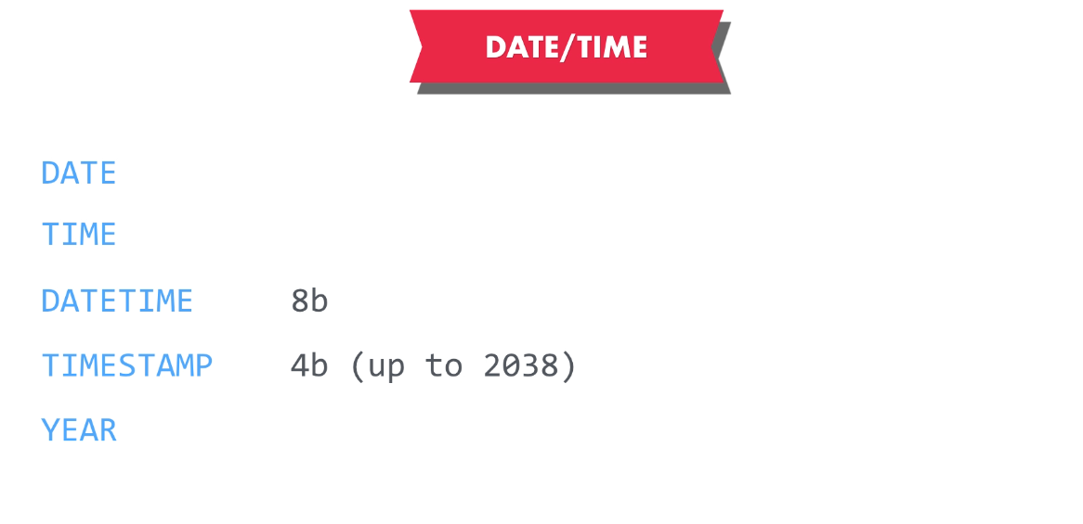

**Blob Types:**

Blob types are generally used to store the binary formats, such as images, videos etc.



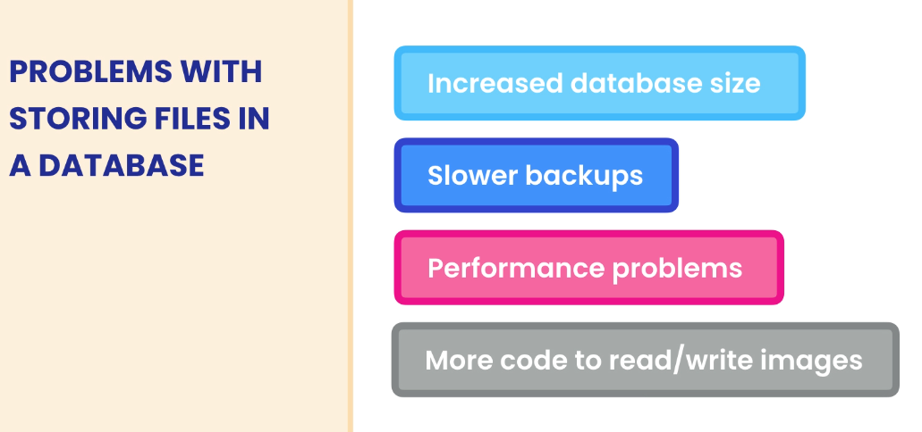

**JSON Types:**

Go to the design mode and then add a new column named employee data and then make it an JSON type.

We can update the property of an table using:

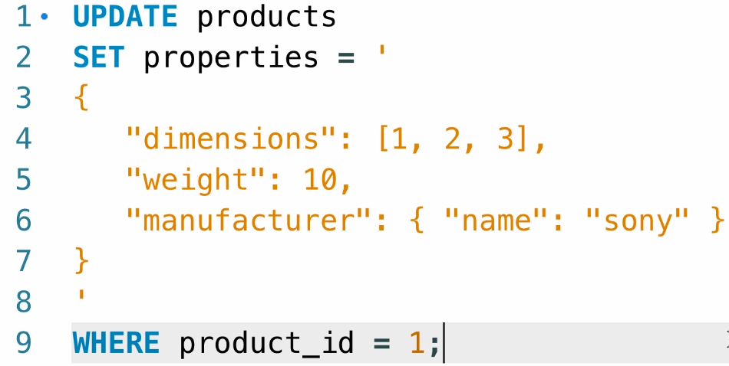

We can rewrite this by using:

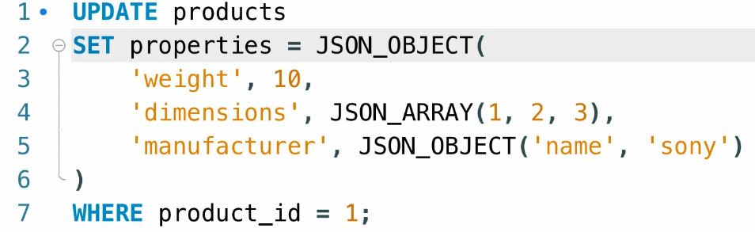

We can fetch the value of the specified key using this:

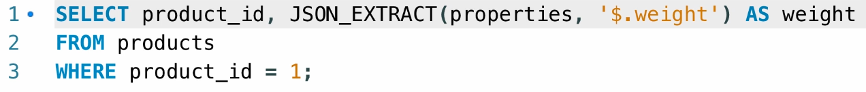

We can also write this as :

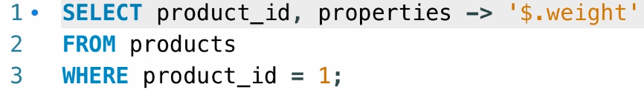

Consider if we are fetching the data from a array then we need to make use of the indexes of the array:

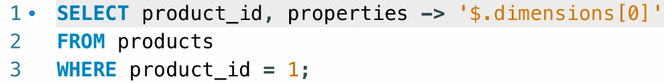

If we want the value inside the complex JSON:

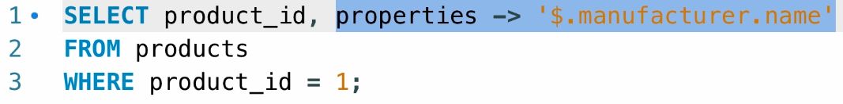

Use the ->> operator to get the value without the “” (double quotes)

We can set the value to the JSON object using:

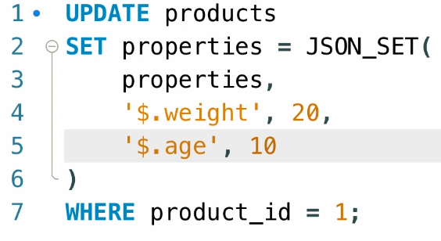

We can also remove the JSON value using:

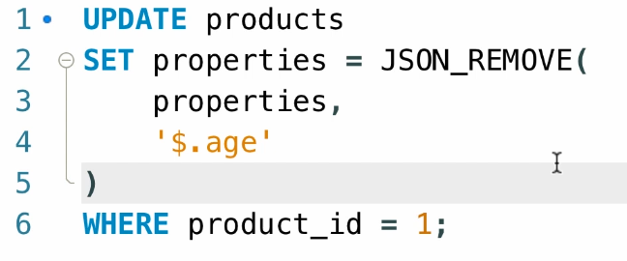

**Designing the DATABASES:**

**Data Modelling:**

Data Modelling involves these steps:

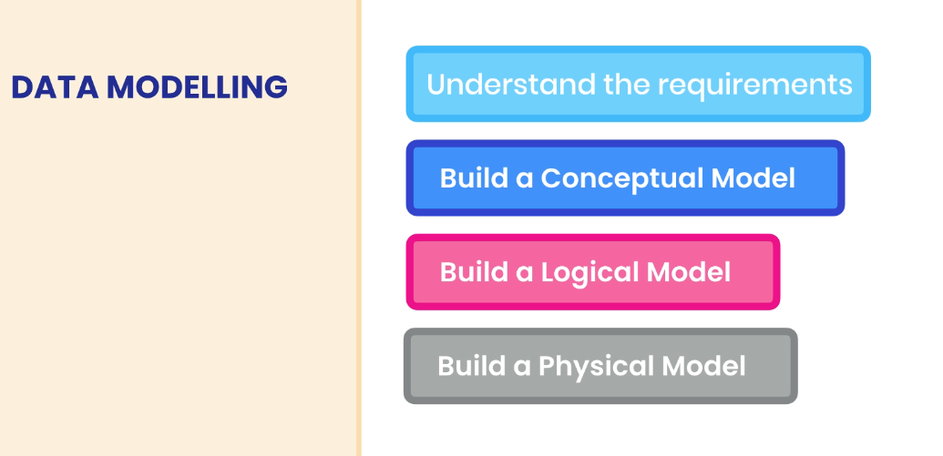

The very important step before building the database, we need to understand the client’s requirement completely and then think of the possible parameters for the database design.

Conceptual Model is just an visual representation of our entire database.

Logical Model is built on the Conceptual model by defining the business logic for the application.

Physical Model includes our tables, Schemas, View, Procedures etc.

**Conceptual Model:**

It represents the entities and relationships of the model. We can represent the things using the ER diagram or else the UML diagram. We use DRAW.IO here.

Popular modelling tools include : MS Visio, LucidCharts, draw.io etc.

We can use these tools to build an ER diagram like this:

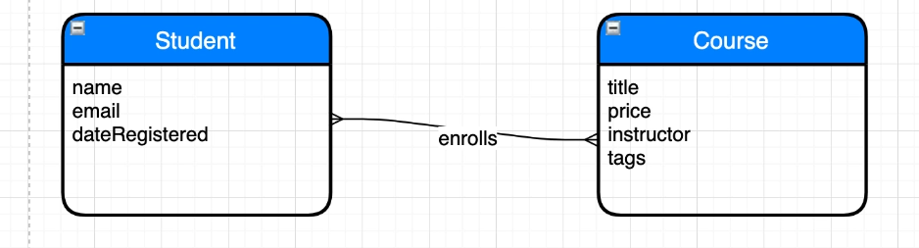

It can be read as **Student** *enrolls* **Course**.

Now we will be using this to build the logical model.

**Logical Models:**

We will be building the business logic for the conceptual model created before.

The different types of the Relationships include:

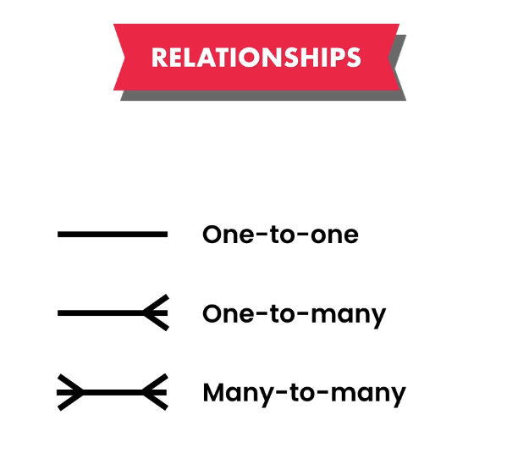

Now we will add the details to the functionality like this:

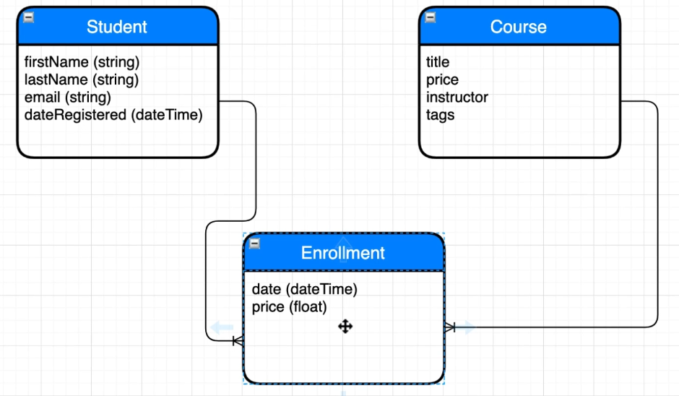

Next we will implement this Logical Model into the Physical Model, that is the tables, Views, Schemas in the MYSQL.